# Title Pages

**Final Project**

 Personal Website Building Application

CWEB2121 and CWEB2111 Spring 2017

Instructors: Christopher Fulton and Amalan Pulendran

**Project Members**

**Charlie Zmuda,**[**Zmucham@dunwoody.edu**](mailto:Zmucham@dunwoody.edu)**, Lead Developer and Creator**

May 17, 2017

## Table of Contents

Title Pages 1

Table of Contents 2

Introduction, Overview, Requirements Specification 4

Overview 4

Requirements 4

Analysis 5

Use Cases 6

Fig 1 6

Fig 2 7

Fig 3 8

Fig 4 9

Design 10

Site Direction: 10

Mock ups 11

Home Page 11

Registration and Login page 11

Store 12

Contact 13

Cart 13

Appointment 14

Entity Relationship Diagram 15

Insert Statements 16

Mental Planning 18

Source Code 19

Config File 19

Index 19

Store 22

Registration 45

Authenticate 50

Login 51

Logout 54

Cart 55

Calendar 59

Implementation 65

Testing and On-going Maintenance 66

Major Revision 1.1 66

Registration 66

Login Page 67

Store Page 68

Cart Page 69

Appointment Page 71

Appendices 74

Appendix A: References 74

# Introduction, Overview, Requirements Specification

## Overview

My application will provide a personalized website building experience. This application will allow the user to pick and choose what they are looking for in a website. For small businesses to personalized websites, this is for the person that does not want to use a do-it-yourself type application like “Wordpress” or “squarespace”. These websites can help a user with building a personalized website, however they are usually very vanilla and similar to other websites by the same publisher. I will provide the user with a personalized one on one experience to help create a website that they will be proud to call their own.

## **Requirements**

Upon viewing the site, the user must be greeted with a welcome page explaining who I am and my website’s purpose. The user must be able to navigate the websites various pages without error. The navigation must include an example Store page, example Cart page, and a calendar/appointment page. The user must register and login to an account in order to view the Cart and Calendar pages. The registration will only take in the basic information of username, password, first name, last name, email, and phone number. After registering the user will be redirected to the login page. After the credentials are verified the user will be sent to the store page to complete the functionality of the site. The user must be logged into an account in order to visibly see and any add-to-cart button. The user will see on the store page various containers that should have various examples of things you would expect to see on a website. This can include but not limited to, buttons, dropdown menus, forms, checkboxes, comment boxes, table and chart examples. The user can comment in a text area under the add-to-cart button and give details into what they would like to do with the items selected. When the user is ready to review their cart, they can choose to go over to cart page. Once at the cart page, the user will see all the items they selected from the store page laid out on a table. The table will show the user the name of the products, the descriptions and the comments that were made for each selection. The user will then be able to edit their comments and if desired, remove items from their list. When ready, the user will be able to view the calendar page and see all available times. The user will be able to click a button to book an appointment and see when other time slots are not available. When a user clicks the book button, they will be unable to see the calendar and only see a message confirming their time and attached will be my personal email address only at that time. The user will be able to contact me directly through my email for any questions.

# Analysis

The main features for application will include the ability to view products, manage a shopping cart, register to become a member and make an appointment. This will require many different coding languages in order to construct a working and efficient program. Primarily I want a new customer to be able to apply for membership, view products listed from my system’s database and manage their cart items for checkout. The next focus is on my applications members. The member will be able to view the database products on the application’s product page. The member will be able to mage their cart items, add, edit and delete shopping cart items. Once the member is complete with their shopping, the member will be able to make an appointment with myself (the websites admin). **Fig 1**

Member can view the products and have the ability to search, browse and view recommended products. When adding products to cart, the member will have to choose a yes or no prompt that double checks whether the user really wants to add the product to their cart. **Fig 2**

Upon viewing the members cart, the system will enable them to add, edit, delete and add comments if they so choose. Once the member clicks on any of these options, the member is confronted with another confirmation prompt to make sure they want to do the action that was chosen. The system responds with the associated response to the action by the member. **Fig 3**

The customer can apply to become a member. When the customer navigates to the registration page, the customer will be presented with multiple fields to enter their personal information in order to record into the systems database. These fields include a username and password which will be confirmed by the system on whether or not the username is already taken and whether or not the password is secure. After which the customer will enter their first name, last name, billing address, shipping address, phone number and email. All this information will then be confirmed by the customer and upon submitting the form, the information will be set into the database and a new customer will become a member. **Fig 4**

After which, the new member will be able to log into their account on the application and their information will be displayed on the correct associated pages. Shopping cart information will be saved to their user account so the member will be able to see their previously set cart information. Once everything above has happened, the member will be able to navigate to an appointment page. This is the part of the application that will let the member pick and choose an available day to set up an appointment with me (the website’s admin). Payment will be done in person and is not part of the system.

## Use Cases

### Fig 1

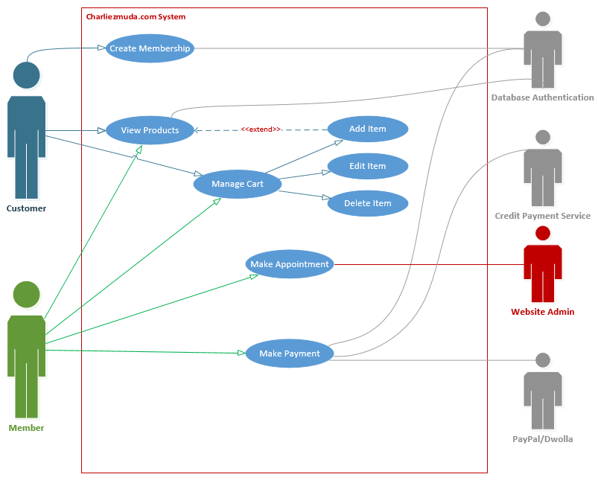

### Fig 2

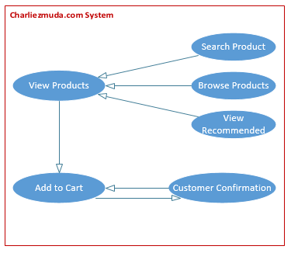

### Fig 3

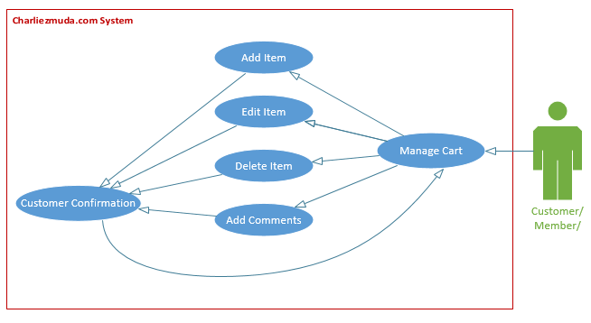

### Fig 4

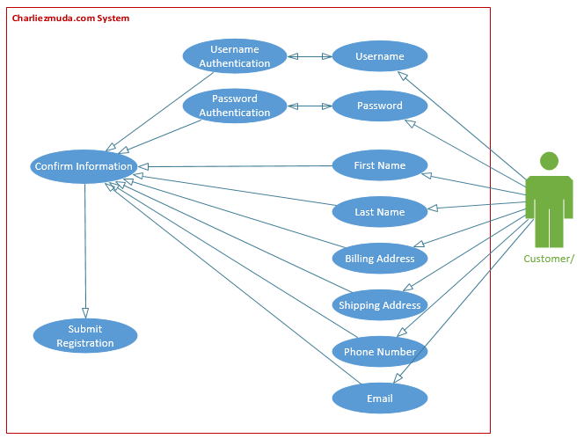

# Design

## Site Direction:

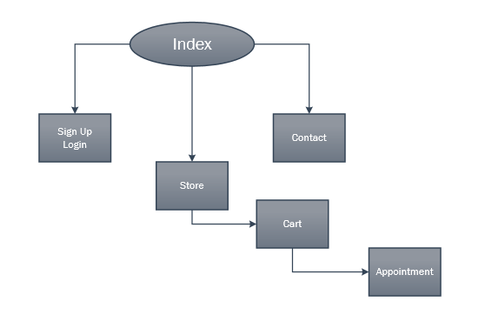

Mock ups:

Home Page:

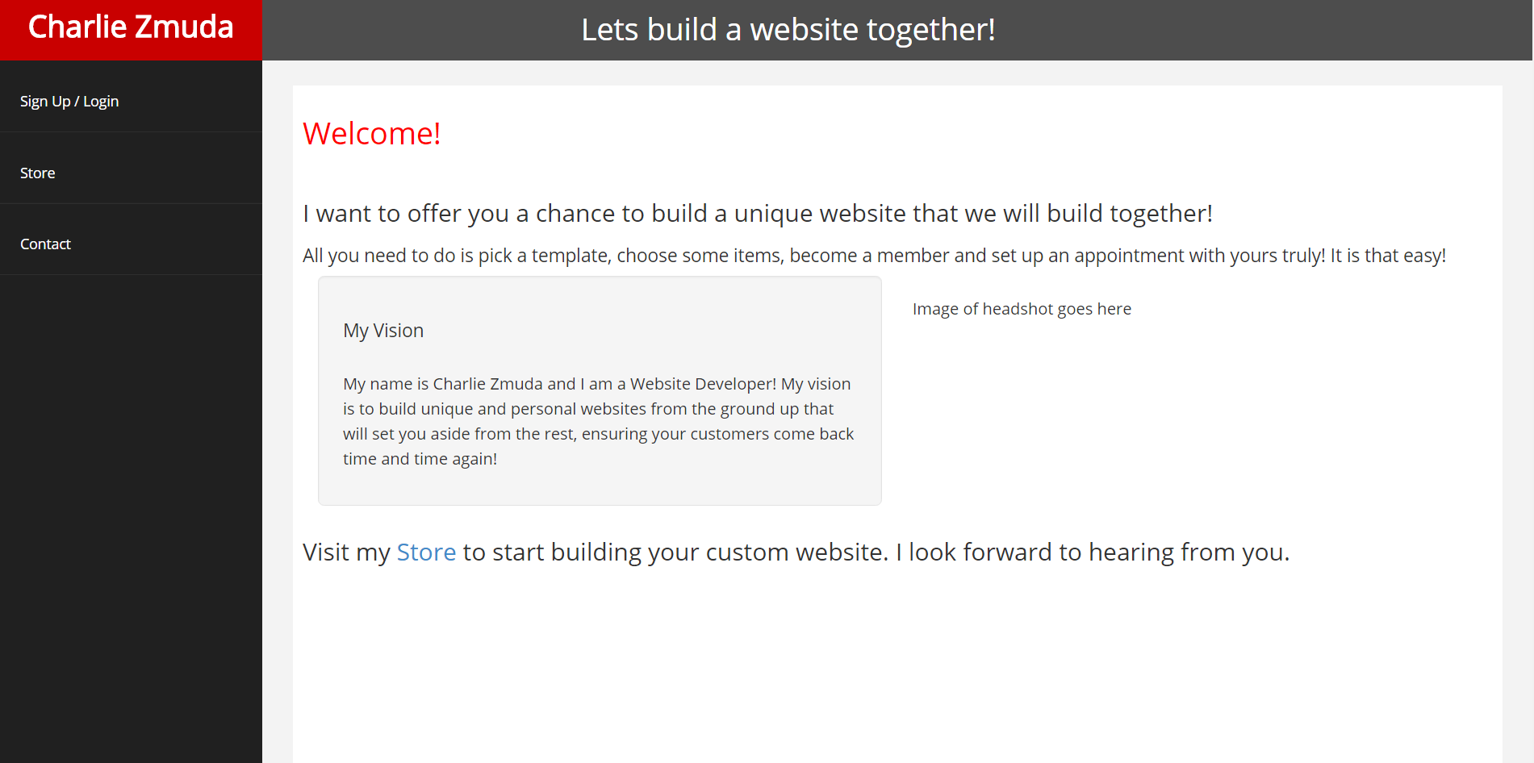

### Registration and Login page

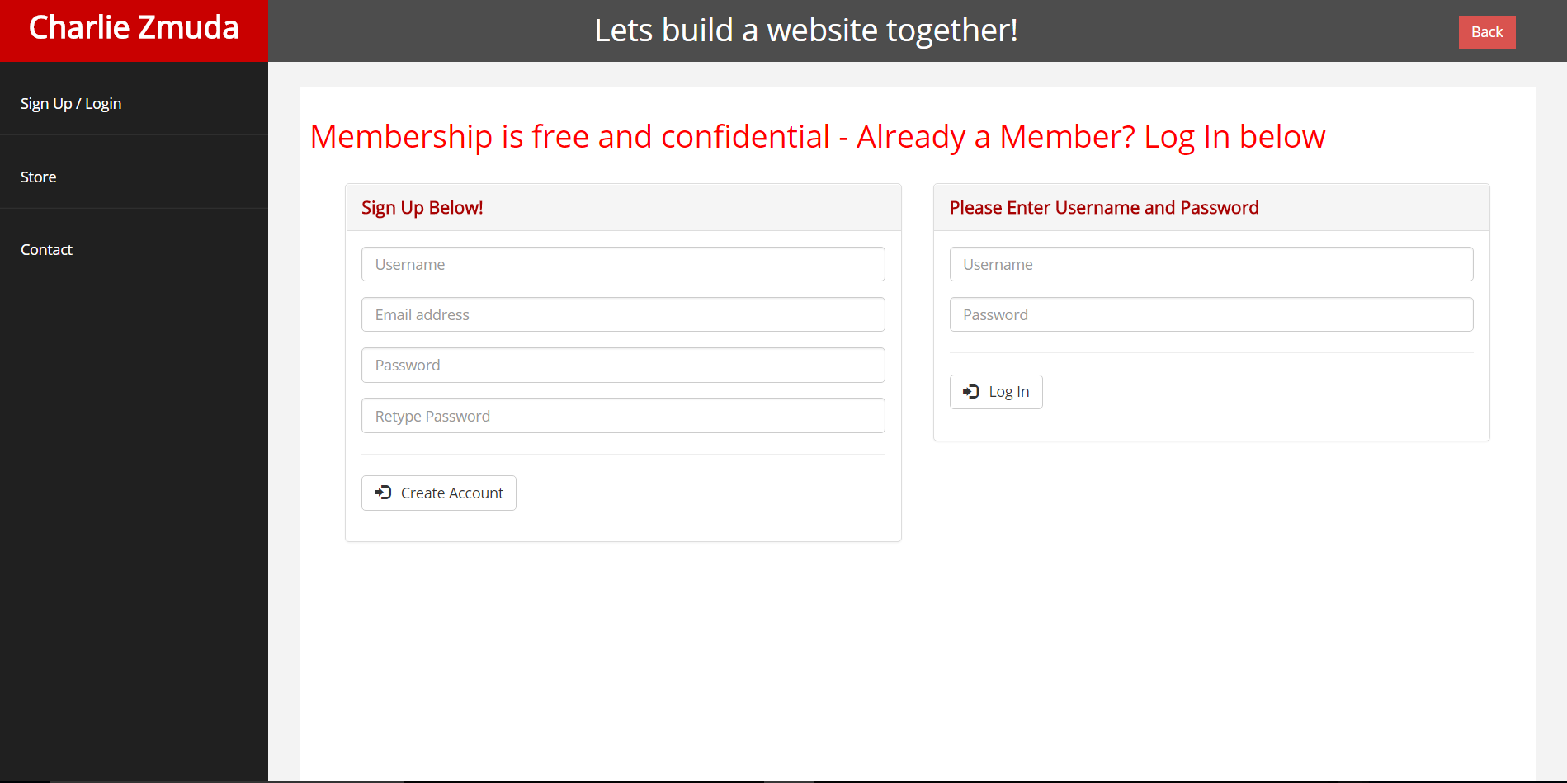

Store:

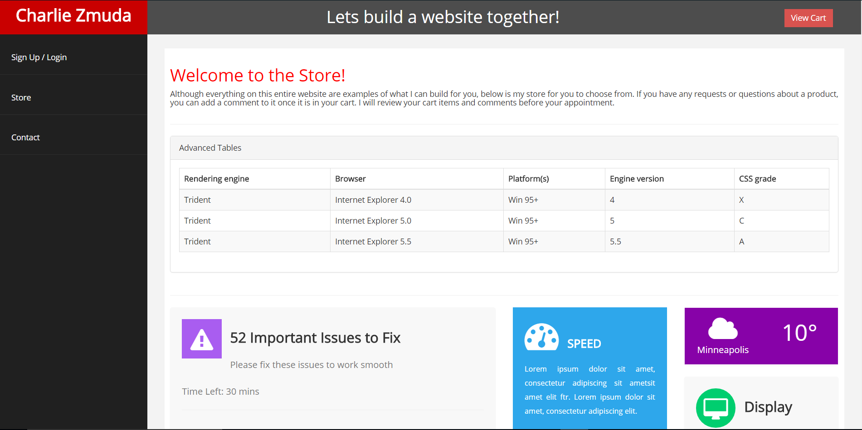

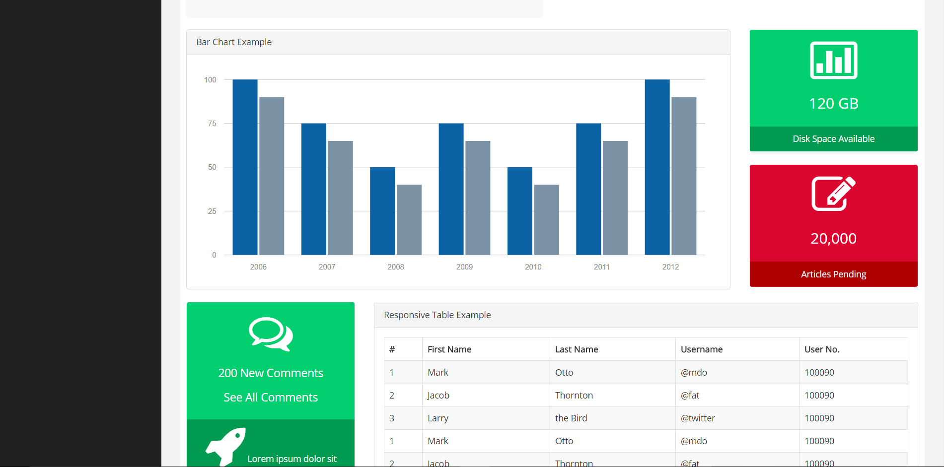

Contact:

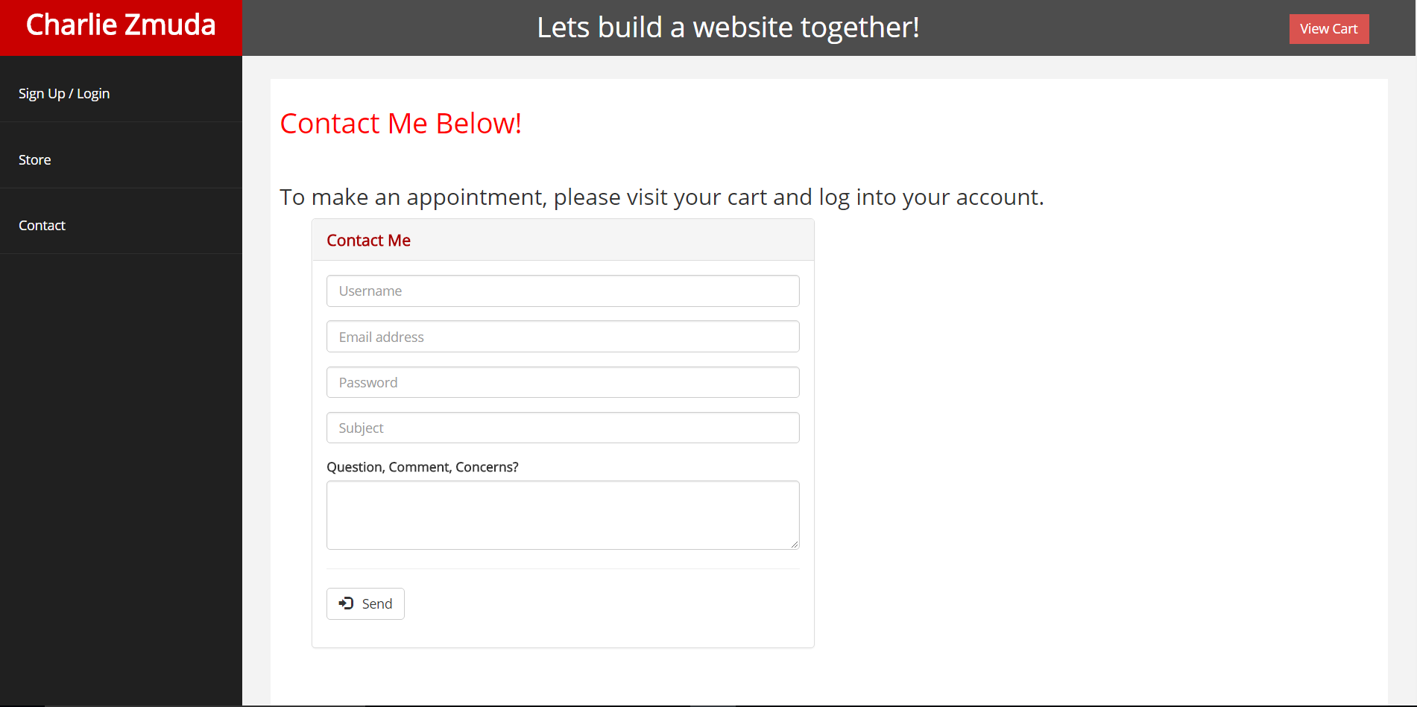

Cart:

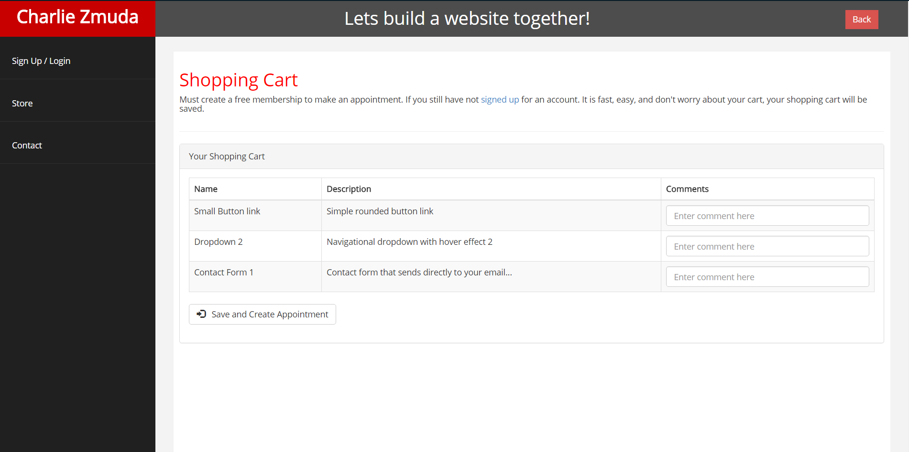

Appointment:

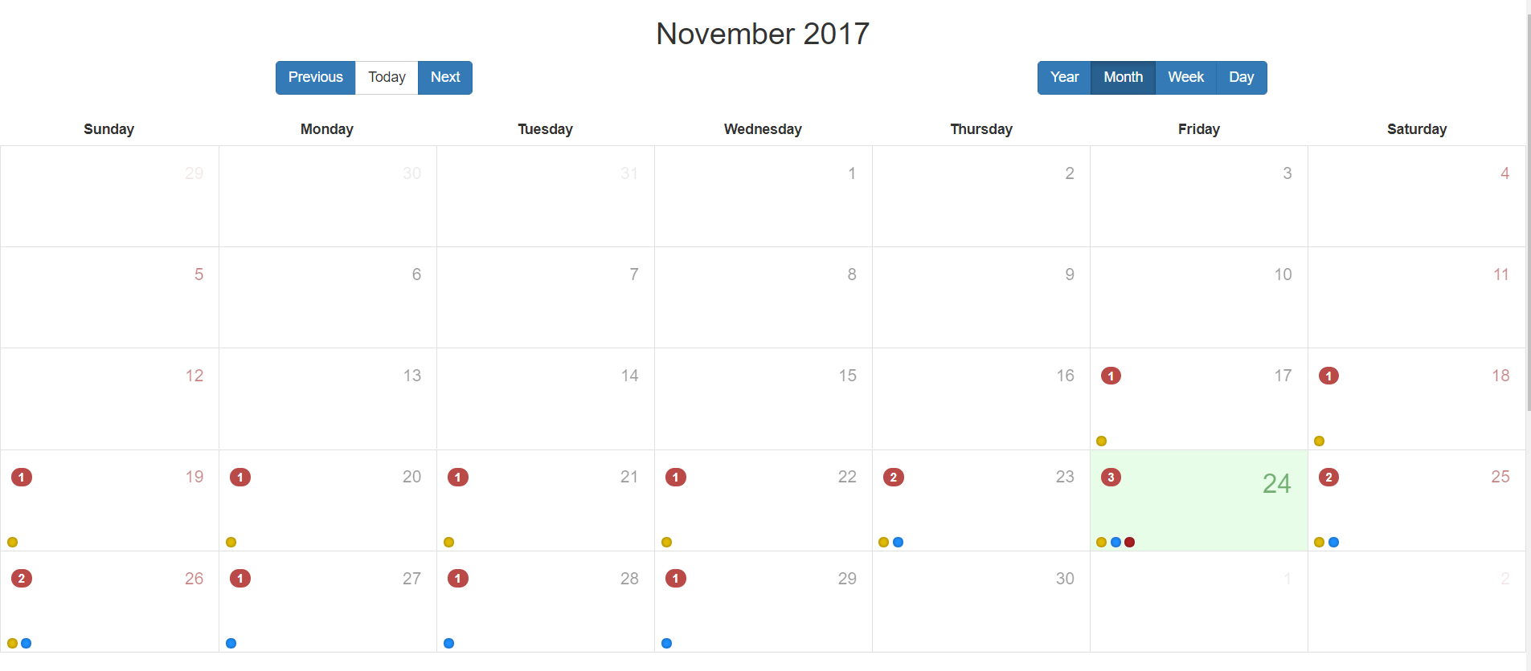

## Entity Relationship Diagram

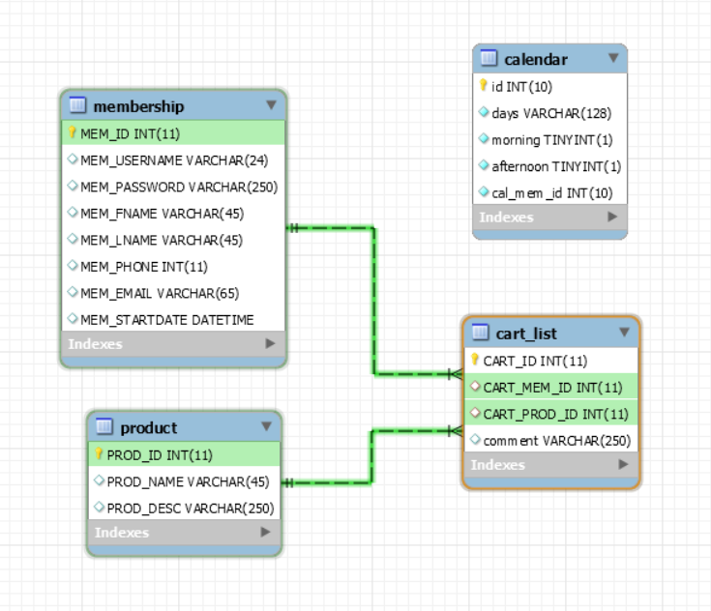

## Insert Statements

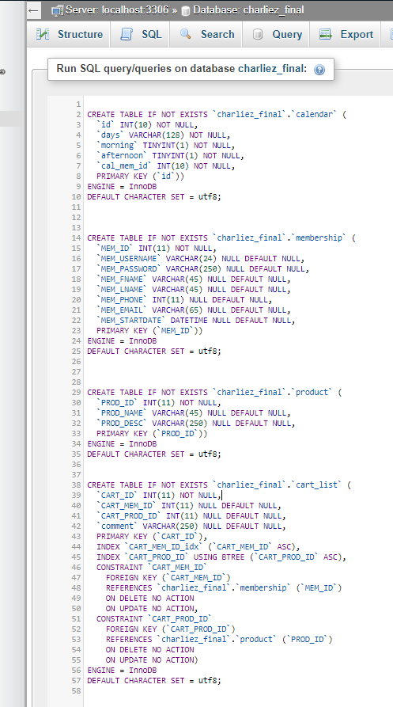

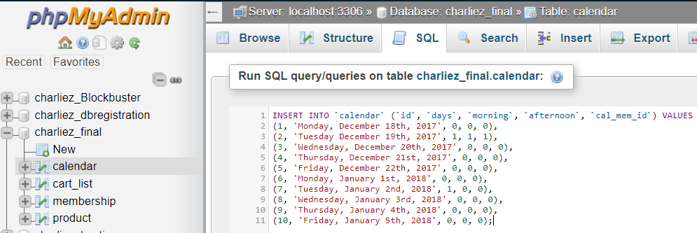

## Mental Planning

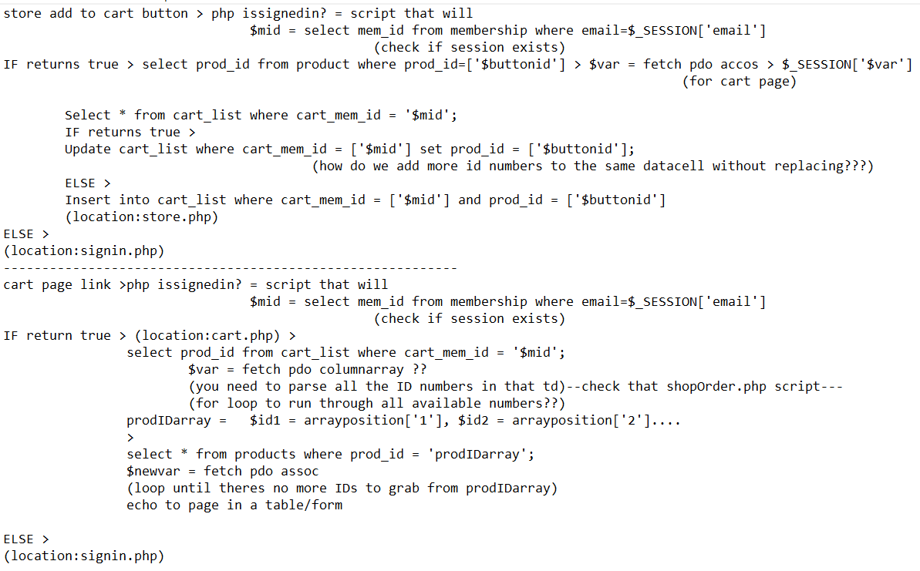

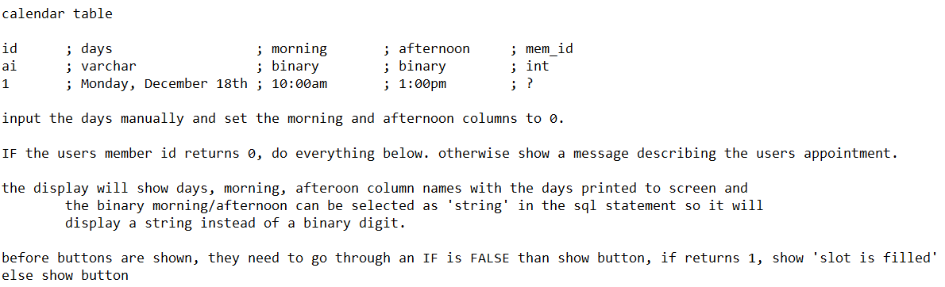

This is the planning that took place in the last stretch of the project before implementing the source code. It is important to understand the concepts of what your building and how they all tie together. This can be a daunting task doing it all in your own head, I chose to write down my thoughts for planning the applications PHP and SQL scripts to produce the output I was attempting to achieve. The calendar application was unexpected and had to be designed at the last moment. Originally I was going to use an API to insert a calendar/appointment application into my site. This costed and unexpected amount of money, so I then had to make my own application. What is shown above is my own thoughts, trying to balance it all in my head was close to impossible.

## Source Code

### Config File

<?php

$db_host = "localhost";

$db_name = "";

$db_user = "";

$db_pass = "";

try{

$db_con = new PDO("mysql:host={$db_host};dbname={$db_name}",$db_user,$db_pass);

$db_con->setAttribute(PDO::ATTR_ERRMODE, PDO::ERRMODE_EXCEPTION);

}

catch(PDOException $e){

echo $e->getMessage();

}

?>

### Index

<html>

<head>

<meta charset="utf-8" />

<meta name="viewport" content="width=device-width, initial-scale=1.0" />

<title>SLC</title>

<!-- BOOTSTRAP STYLES-->

<link href="assets/css/bootstrap.css" rel="stylesheet" />

<!-- FONTAWESOME STYLES-->

<link href="assets/css/font-awesome.css" rel="stylesheet" />

<!-- CUSTOM STYLES-->

<link href="assets/css/custom.css" rel="stylesheet" />

<!-- GOOGLE FONTS-->

<link href='http://fonts.googleapis.com/css?family=Open+Sans' rel='stylesheet' type='text/css' />

</head>

<body>

<div id="wrapper">

<nav class=" navbar-default navbar-cls-top " role="navigation" style="margin-bottom: 0">

<div class="sidebar-collapse form-inline" align="center">

<ul class="nav form-inline" style="text-align:center; margin-top:5px;">

<a style="font-size:36pt;" class="navbar-brand col-sm-10" href="index.php">Personal Website Building</a>

<li><a href="store.php" style="text-align:center; font-size:24pt; " ><i class="fa fa-3x"></i> Store </a></li>

<li><a href="cart.php" style="text-align:center; font-size:24pt; " ><i class="fa fa-3x"></i> Cart </a></li>

<li><a href="calendar.php" style="text-align:center; font-size:24pt; " ><i class="fa fa-3x"></i> Appointment </a></li>

<?php if(isset($_SESSION['sess_username'])){ $name = $_SESSION['sess_username'];?>

<div style="color: white;padding: 5px 5px 5px 5px;float: right;font-size: 16px;"><?php echo "Welcome ". $name;?> &nbsp;

<a href="logout.php" class="btn btn-danger square-btn-adjust">Log Out</a> </div>

<?php } else { ?>

<div style="color: white;padding: 10px 5px 5px 5px;float: right;font-size: 16px;"> &nbsp;

<a href="login.php" class="btn btn-primary square-btn-adjust">Sign In</a> </div>

<div style="color: white;padding: 10px 5px 5px 5px;float: right;font-size: 16px;"> &nbsp;

<a href="registration.php" class="btn btn-danger square-btn-adjust">Sign Up</a> </div>

<?php } ?>

</ul>

</div>

</nav>

<!-- /. NAV SIDE -->

<div id="page-wrapper" >

<div id="page-inner">

<div class="row">

<div class="col-md-12">

<h2>Welcome</h2><br/>

<div class="col-md-2"></div>

<div class="col-md-8">

<h3>My name is Charlie Zmuda and I build custom websites!<br/>

<br/>Check out some examples in my store!<br/>

<br/> Create an account and become a free member!<br/>

<br/>This is not a real store, more of an example and demonstration. Once you have explored the site, tell me about your needs on the store page and confirm a meeting time.<br/>

<br/>Together we will build a unique and personal website!</h3>

</div>

<div class="col-md-2"></div><br/>

</div><!--PAGE INNER INNER-->

</div><!-- /. ROW -->

</div><!-- PAGE INNER -->

</div><!-- PAGE WRAPPER -->

</div><!-- WRAPPER -->

<!-- SCRIPTS -AT THE BOTTOM TO REDUCE THE LOAD TIME-->

<!-- JQUERY SCRIPTS -->

<script src="assets/js/jquery-1.10.2.js"></script>

<!-- BOOTSTRAP SCRIPTS -->

<script src="assets/js/bootstrap.min.js"></script>

<!-- METISMENU SCRIPTS -->

<script src="assets/js/jquery.metisMenu.js"></script>

<!-- DATA TABLE SCRIPTS -->

<script src="assets/js/dataTables/jquery.dataTables.js"></script>

<script src="assets/js/dataTables/dataTables.bootstrap.js"></script>

<script>

$(document).ready(function () {

$('#dataTables-example').dataTable();

});

</script>

<!-- CUSTOM SCRIPTS -->

<script src="assets/js/custom.js"></script>

</body>

</html>

### Store

<?php

session_start();

include('dbconfig.php');

if(isset($_POST['submit'])){

$mid = $_SESSION['sess_user_id'];

$id = $_POST['product'];

$comm = $_POST['comment'];

try{

$stmt = $db_con->prepare("INSERT INTO cart_list(cart_mem_id,cart_prod_id,comment) VALUES(:mem_id, :prod_id, :comm)");

$stmt->bindParam(":mem_id",$mid);

$stmt->bindParam(":prod_id",$id);

$stmt->bindParam(":comm",$comm);

if($stmt->execute())

{

header("Location:store.php");

}

}//end of try

catch(PDOException $e){

echo $e->getMessage();

}

}

?>

<html>

<head>

<meta charset="utf-8" />

<meta name="viewport" content="width=device-width, initial-scale=1.0" />

<title>SLC</title>

<!-- BOOTSTRAP STYLES-->

<link href="assets/css/bootstrap.css" rel="stylesheet" />

<!-- FONTAWESOME STYLES-->

<link href="assets/css/font-awesome.css" rel="stylesheet" />

<!-- CUSTOM STYLES-->

<link href="assets/css/custom.css" rel="stylesheet" />

<!-- GOOGLE FONTS-->

<link href='http://fonts.googleapis.com/css?family=Open+Sans' rel='stylesheet' type='text/css' />

</head>

<body>

<div id="wrapper">

<nav class=" navbar-default navbar-cls-top " role="navigation" style="margin-bottom: 0">

<div class="sidebar-collapse form-inline" align="center">

<ul class="nav form-inline" style="text-align:center; margin-top:5px;">

<a style="font-size:36pt;" class="navbar-brand col-sm-10" href="index.php">Personal Website Building</a>

<li><a href="store.php" style="text-align:center; font-size:24pt; " ><i class="fa fa-3x"></i> Store </a></li>

<li><a href="cart.php" style="text-align:center; font-size:24pt; " ><i class="fa fa-3x"></i> Cart </a></li>

<li><a href="calendar.php" style="text-align:center; font-size:24pt; " ><i class="fa fa-3x"></i> Appointment </a></li>

<?php if(isset($_SESSION['sess_username'])){ $name = $_SESSION['sess_username'];?>

<div style="color: white;padding: 5px 5px 5px 5px;float: right;font-size: 16px;"><?php echo "Welcome ". $name;?> &nbsp;

<a href="logout.php" class="btn btn-danger square-btn-adjust">Log Out</a> </div>

<?php } else { ?>

<div style="color: white;padding: 10px 5px 5px 5px;float: right;font-size: 16px;"> &nbsp;

<a href="login.php" class="btn btn-primary square-btn-adjust">Sign In</a> </div>

<div style="color: white;padding: 10px 5px 5px 5px;float: right;font-size: 16px;"> &nbsp;

<a href="registration.php" class="btn btn-danger square-btn-adjust">Sign Up</a> </div>

<?php } ?>

</ul>

</div>

</nav>

<!-- /. NAV SIDE -->

<div id="page-wrapper" >

<div id="page-inner">

<div class="row">

<div class="col-md-12 ">

<h2 style="color: #fff; text-align:center;">Here are examples of what I can build for you! </h2>

<br/>&nbsp;<h3 style="color: #ffd820; text-align:left;">But first I need some information...</h3>

<h4 style="color: #fff; text-align:left;">

<ol>

<li>Must be logged into your free account</li>

<li>If you see something you want on your site, leave me a comment and tell me more!</li>

<li>Everything you write will be discussed at our meeting</li>

<li>Click the Add To Cart button!</li>

</ol>

</h4>

<h3 style="color: #fff; text-align:center;">When ready, review your "<a href="cart.php" style="color:#ffd820;" >Shopping Cart</a>" example and schedule a meeting!</h3>

</div>

<div class="row">

<div class="col-md-5">

<div class="panel panel-default">

<div class="panel-heading"></div>

<div class="panel-body shadow">

<?php if(isset($_SESSION['sess_username'])){ ?>

<form method="POST" role="form" id="register-form">

<div class="form-group">

<button type="submit" class="btn btn-default" name="submit">

<span class="glyphicon glyphicon-log-in"></span> &nbsp; Add to Cart</button>

<br/><br/>

<input type="text" name="comment" class="form-control" placeholder="Comment">

<input type="hidden" name="product" value="1">

</div>

<hr/>

</form>

<?php } else { ?>

<?php } ?>

<h3>Simple Button Examples</h3>

<h4>Default Button</h4>

<a href="#" class="btn btn-default">default</a>

<a href="#" class="btn btn-primary">primary</a>

<a href="#" class="btn btn-danger">danger</a>

<a href="#" class="btn btn-success">success</a>

<a href="#" class="btn btn-info">info</a>

<a href="#" class="btn btn-warning">warning</a>

<h4>Small Button</h4>

<a href="#" class="btn btn-default btn-sm">default</a>

<a href="#" class="btn btn-primary btn-sm">primary</a>

<a href="#" class="btn btn-danger btn-sm">danger</a>

<a href="#" class="btn btn-success btn-sm">success</a>

<a href="#" class="btn btn-info btn-sm">info</a>

<a href="#" class="btn btn-warning btn-sm">warning</a>

<h4>Large Button</h4>

<a href="#" class="btn btn-default btn-lg">default</a>

<a href="#" class="btn btn-primary btn-lg">primary</a>

<a href="#" class="btn btn-danger btn-lg">danger</a>

<a href="#" class="btn btn-success btn-lg">success</a>

<a href="#" class="btn btn-info btn-lg">info</a>

</div>

</div>

</div>

<div class="col-md-1"></div>

<div class="col-md-5">

<div class="panel panel-default">

<div class="panel-heading"></div>

<div class="panel-body shadow">

<?php if(isset($_SESSION['sess_username'])){ ?>

<form method="POST" role="form" id="register-form">

<div class="form-group">

<button type="submit" class="btn btn-default" name="submit">

<span class="glyphicon glyphicon-log-in"></span> &nbsp; Add to Cart</button>

<br/><br/>

<input type="text" name="comment" class="form-control" placeholder="Comment">

<input type="hidden" name="product" value="2">

</div>

<hr/>

</form>

<?php } else { ?>

<?php } ?>

<h3>Icons Provided By Font-Awesome!</h3>

<h4>Button Dropdown Examples</h4>

<div style="margin-top: 10px;">

<div class="btn-group">

<button data-toggle="dropdown" class="btn btn-primary dropdown-toggle">Action <span class="caret"></span></button>

<ul class="dropdown-menu">

<li><a href="#">Action</a></li>

<li><a href="#">Another action</a></li>

<li><a href="#">Something else here</a></li>

<li class="divider"></li>

<li><a href="#">Separated link</a></li>

</ul>

</div>

<div style="margin:5px;" class="btn-group">

<button data-toggle="dropdown" class="btn btn-danger dropdown-toggle">Danger <span class="caret"></span></button>

<ul class="dropdown-menu">

<li><a href="#">Action</a></li>

<li><a href="#">Another action</a></li>

<li><a href="#">Something else here</a></li>

<li class="divider"></li>

<li><a href="#">Separated link</a></li>

</ul>

</div>

<div style="margin:5px;" class="btn-group">

<button data-toggle="dropdown" class="btn btn-warning dropdown-toggle">Danger <span class="caret"></span></button>

<ul class="dropdown-menu">

<li><a href="#">Action</a></li>

<li><a href="#">Another action</a></li>

<li><a href="#">Something else here</a></li>

<li class="divider"></li>

<li><a href="#">Separated link</a></li>

</ul>

</div>

</div>

<div>

<div class="btn-group">

<button data-toggle="dropdown" class="btn btn-success dropdown-toggle">Success <span class="caret"></span></button>

<ul class="dropdown-menu">

<li><a href="#">Action</a></li>

<li><a href="#">Another action</a></li>

<li><a href="#">Something else here</a></li>

<li class="divider"></li>

<li><a href="#">Separated link</a></li>

</ul>

</div>

<div class="btn-group">

<button data-toggle="dropdown" class="btn btn-info dropdown-toggle">Info <span class="caret"></span></button>

<ul class="dropdown-menu">

<li><a href="#">Action</a></li>

<li><a href="#">Another action</a></li>

<li><a href="#">Something else here</a></li>

<li class="divider"></li>

<li><a href="#">Separated link</a></li>

</ul>

</div>

<div class="btn-group">

<button data-toggle="dropdown" class="btn btn-default dropdown-toggle">Default <span class="caret"></span></button>

<ul class="dropdown-menu">

<li><a href="#">Action</a></li>

<li><a href="#">Another action</a></li>

<li><a href="#">Something else here</a></li>

<li class="divider"></li>

<li><a href="#">Separated link</a></li>

</ul>

</div>

</div>

<h4>Buttons With Icons</h4>

<button class="btn btn-default"><i class=" fa fa-refresh "></i> Update</button>

<button class="btn btn-primary"><i class="fa fa-edit "></i> Edit</button>

<button class="btn btn-danger"><i class="fa fa-pencil"></i> Delete</button>

</div><!--end of panel body-->

</div><!--end of panel-->

</div><!--end of col-md-5-->

</div><!--end of row for buttons-->

<div class="row">

<div class="col-md-5">

<div class="panel panel-default">

<div class="panel-heading"></div>

<div class="panel-body shadow">

<?php if(isset($_SESSION['sess_username'])){ ?>

<form method="POST" role="form" id="register-form">

<div class="form-group">

<button type="submit" class="btn btn-default" name="submit">

<span class="glyphicon glyphicon-log-in"></span> &nbsp; Add to Cart</button>

<br/><br/>

<input type="text" name="comment" class="form-control" placeholder="Comment">

<input type="hidden" name="product" value="3">

</div>

<hr/>

</form>

<?php } else { ?>

<?php } ?>

<h3>With radio &amp; checkboxes</h3>

<div class="form-group">

<label>Checkboxes</label>

<div class="checkbox">

<label>

<input type="checkbox" value="">Checkbox Example One

</label>

</div>

<div class="checkbox">

<label>

<input type="checkbox" value="">Checkbox Example Two

</label>

</div>

<div class="checkbox">

<label>

<input type="checkbox" value="">Checkbox Example Three

</label>

</div>

</div>

<div class="form-group">

<label>Inline Checkboxes Examples</label>

<label class="checkbox-inline">

<input type="checkbox"> One

</label>

<label class="checkbox-inline">

<input type="checkbox"> Two

</label>

<label class="checkbox-inline">

<input type="checkbox"> Three

</label>

</div>

<div class="form-group">

<label>Radio Button Examples</label>

<div class="radio">

<label>

<input type="radio" name="optionsRadios" id="optionsRadios1" value="option1" checked="">Radio Example One

</label>

</div>

<div class="radio">

<label>

<input type="radio" name="optionsRadios" id="optionsRadios2" value="option2">Radio Example Two

</label>

</div>

<div class="radio">

<label>

<input type="radio" name="optionsRadios" id="optionsRadios3" value="option3">Radio Example Three

</label>

</div>

</div>

</div>

</div>

</div>

<div class="col-md-1"></div>

<div class="col-md-5">

<div class="panel panel-default">

<div class="panel-heading"></div>

<div class="panel-body shadow">

<?php if(isset($_SESSION['sess_username'])){ ?>

<form method="POST" role="form" id="register-form">

<div class="form-group">

<button type="submit" class="btn btn-default" name="submit">

<span class="glyphicon glyphicon-log-in"></span> &nbsp; Add to Cart</button>

<br/><br/>

<input type="text" name="comment" class="form-control" placeholder="Comment">

<input type="hidden" name="product" value="4">

</div>

<hr/>

</form>

<?php } else { ?>

<?php } ?>

<h3>Basic Form Examples</h3>

<div class="form-group">

<label>Select Example</label>

<select class="form-control">

<option>One</option>

<option>Two</option>

<option>Three</option>

<option>Four</option>

</select>

</div>

<div class="form-group">

<label>Multiple Select Example</label>

<select multiple="" class="form-control">

<option>One</option>

<option>Two</option>

<option>Three</option>

<option>Four</option>

</select>

</div>

<button type="submit" class="btn btn-default">Submit Button</button>

<button type="reset" class="btn btn-primary">Reset Button</button>

<br>

</div>

</div>

</div>

</div><!--end of row-->

<div class="row">

<div class="col-md-5">

<div class="panel panel-default">

<div class="panel-heading"></div>

<div class="panel-body shadow">

<?php if(isset($_SESSION['sess_username'])){ ?>

<form method="POST" role="form" id="register-form">

<div class="form-group">

<button type="submit" class="btn btn-default" name="submit">

<span class="glyphicon glyphicon-log-in"></span> &nbsp; Add to Cart</button>

<br/><br/>

<input type="text" name="comment" class="form-control" placeholder="Comment">

<input type="hidden" name="product" value="5">

</div>

<hr/>

</form>

<?php } else { ?>

<?php } ?>

<h3>Registration Form Example!</h3>

<h4>Just need some info to begin your free membership! <span class="glyphicon glyphicon-user"/></h4><br/>

<form method="" class="form-signin col-md-8 col-md-offset-2" >

<div class="form-group">

<label>Username</label>

<input type="text" name="" class="form-control" placeholder="Username" ><br/>

<label>Password</label>

<input type="password" name="" class="form-control" placeholder="Password"><br/>

<label>Email</label>

<input type="email" name="" class="form-control" placeholder="Email address" id="user_email"/><br/>

<div class="form-group">

<button type="submit" class="btn btn-default" name="">

<span class="glyphicon glyphicon-log-in"></span> &nbsp; Create Account</button>

</div>

</div>

</form>

</div>

</div>

</div>

<div class="col-md-1"></div>

<div class="col-md-5">

<div class="panel panel-default">

<div class="panel-heading"></div>

<div class="panel-body shadow">

<?php if(isset($_SESSION['sess_username'])){ ?>

<form method="POST" role="form" id="register-form">

<div class="form-group">

<button type="submit" class="btn btn-default" name="submit">

<span class="glyphicon glyphicon-log-in"></span> &nbsp; Add to Cart</button>

<br/><br/>

<input type="text" name="comment" class="form-control" placeholder="Comment">

<input type="hidden" name="product" value="6">

</div>

<hr/>

</form>

<?php } else { ?>

<?php } ?>

<h3>Login Form Example</h3>

<h4>Please enter your username and password <span class="glyphicon glyphicon-user"/></h4><br/>

<form action="" class="form-signin col-md-8 col-md-offset-2" role="form">

<div class="form-group">

<input type="text" class="form-control" placeholder="Username" ><br/>

<input type="password" class="form-control" placeholder="Password" ><br/>

<button class="btn btn-primary btn-lg square-btn-adjust" type="">Sign In</button>

</div>

<div class="form-group" style="float:right;">

<p style=" font-size:16pt;">Not a free member yet?</p>

<a style="float:right;" href="" class="btn btn-danger square-btn-adjust" role="button">Register</a>

</div>

</form>

</div>

</div>

</div>

</div><!--end of row-->

<div class="row">

<div class="col-md-12">

<!-- Advanced Tables -->

<div class="panel panel-default">

<div class="panel-heading"></div>

<div class="panel-body shadow">

<?php if(isset($_SESSION['sess_username'])){ ?>

<form method="POST" role="form" id="register-form">

<div class="form-group">

<button type="submit" class="btn btn-default" name="submit">

<span class="glyphicon glyphicon-log-in"></span> &nbsp; Add to Cart</button>

<br/><br/>

<input type="text" name="comment" class="form-control" placeholder="Comment">

<input type="hidden" name="product" value="7">

</div>

<hr/>

</form>

<?php } else { ?>

<?php } ?>

<h3>Advanced Table Functionality!</h3>

<div class="table-responsive">

<table class="table table-bordered table-hover" id="dataTables-example">

<thead>

<tr>

<th>Rendering engine</th>

<th>Browser</th>

<th>Platform(s)</th>

<th>Engine version</th>

<th>CSS grade</th>

</tr>

</thead>

<tbody>

<tr class="odd gradeX">

<td>Trident</td>

<td>Internet Explorer 4.0</td>

<td>Win 95+</td>

<td class="center">4</td>

<td class="center">X</td>

</tr>

<tr class="even gradeC">

<td>Trident</td>

<td>Internet Explorer 5.0</td>

<td>Win 95+</td>

<td class="center">5</td>

<td class="center">C</td>

</tr>

<tr class="odd gradeA">

<td>Trident</td>

<td>Internet Explorer 5.5</td>

<td>Win 95+</td>

<td class="center">5.5</td>

<td class="center">A</td>

</tr>

<tr class="even gradeA">

<td>Trident</td>

<td>Internet Explorer 6</td>

<td>Win 98+</td>

<td class="center">6</td>

<td class="center">A</td>

</tr>

<tr class="odd gradeA">

<td>Trident</td>

<td>Internet Explorer 7</td>

<td>Win XP SP2+</td>

<td class="center">7</td>

<td class="center">A</td>

</tr>

<tr class="even gradeA">

<td>Trident</td>

<td>AOL browser (AOL desktop)</td>

<td>Win XP</td>

<td class="center">6</td>

<td class="center">A</td>

</tr>

<tr class="gradeA">

<td>Gecko</td>

<td>Firefox 1.0</td>

<td>Win 98+ / OSX.2+</td>

<td class="center">1.7</td>

<td class="center">A</td>

</tr>

<tr class="gradeA">

<td>Gecko</td>

<td>Firefox 1.5</td>

<td>Win 98+ / OSX.2+</td>

<td class="center">1.8</td>

<td class="center">A</td>

</tr>

<tr class="gradeA">

<td>Gecko</td>

<td>Firefox 2.0</td>

<td>Win 98+ / OSX.2+</td>

<td class="center">1.8</td>

<td class="center">A</td>

</tr>

<tr class="gradeA">

<td>Gecko</td>

<td>Firefox 3.0</td>

<td>Win 2k+ / OSX.3+</td>

<td class="center">1.9</td>

<td class="center">A</td>

</tr>

<tr class="gradeA">

<td>Gecko</td>

<td>Camino 1.0</td>

<td>OSX.2+</td>

<td class="center">1.8</td>

<td class="center">A</td>

</tr>

<tr class="gradeA">

<td>Gecko</td>

<td>Camino 1.5</td>

<td>OSX.3+</td>

<td class="center">1.8</td>

<td class="center">A</td>

</tr>

<tr class="gradeA">

<td>Gecko</td>

<td>Netscape 7.2</td>

<td>Win 95+ / Mac OS 8.6-9.2</td>

<td class="center">1.7</td>

<td class="center">A</td>

</tr>

<tr class="gradeA">

<td>Gecko</td>

<td>Netscape Browser 8</td>

<td>Win 98SE+</td>

<td class="center">1.7</td>

<td class="center">A</td>

</tr>

<tr class="gradeA">

<td>Gecko</td>

<td>Netscape Navigator 9</td>

<td>Win 98+ / OSX.2+</td>

<td class="center">1.8</td>

<td class="center">A</td>

</tr>

<tr class="gradeA">

<td>Gecko</td>

<td>Mozilla 1.0</td>

<td>Win 95+ / OSX.1+</td>

<td class="center">1</td>

<td class="center">A</td>

</tr>

<tr class="gradeA">

<td>Gecko</td>

<td>Mozilla 1.1</td>

<td>Win 95+ / OSX.1+</td>

<td class="center">1.1</td>

<td class="center">A</td>

</tr>

<tr class="gradeA">

<td>Gecko</td>

<td>Mozilla 1.2</td>

<td>Win 95+ / OSX.1+</td>

<td class="center">1.2</td>

<td class="center">A</td>

</tr>

<tr class="gradeA">

<td>Gecko</td>

<td>Mozilla 1.3</td>

<td>Win 95+ / OSX.1+</td>

<td class="center">1.3</td>

<td class="center">A</td>

</tr>

<tr class="gradeA">

<td>Gecko</td>

<td>Mozilla 1.4</td>

<td>Win 95+ / OSX.1+</td>

<td class="center">1.4</td>

<td class="center">A</td>

</tr>

<tr class="gradeA">

<td>Gecko</td>

<td>Mozilla 1.5</td>

<td>Win 95+ / OSX.1+</td>

<td class="center">1.5</td>

<td class="center">A</td>

</tr>

<tr class="gradeA">

<td>Gecko</td>

<td>Mozilla 1.6</td>

<td>Win 95+ / OSX.1+</td>

<td class="center">1.6</td>

<td class="center">A</td>

</tr>

<tr class="gradeA">

<td>Gecko</td>

<td>Mozilla 1.7</td>

<td>Win 98+ / OSX.1+</td>

<td class="center">1.7</td>

<td class="center">A</td>

</tr>

<tr class="gradeA">

<td>Gecko</td>

<td>Mozilla 1.8</td>

<td>Win 98+ / OSX.1+</td>

<td class="center">1.8</td>

<td class="center">A</td>

</tr>

<tr class="gradeA">

<td>Gecko</td>

<td>Seamonkey 1.1</td>

<td>Win 98+ / OSX.2+</td>

<td class="center">1.8</td>

<td class="center">A</td>

</tr>

<tr class="gradeA">

<td>Gecko</td>

<td>Epiphany 2.20</td>

<td>Gnome</td>

<td class="center">1.8</td>

<td class="center">A</td>

</tr>

<tr class="gradeA">

<td>Webkit</td>

<td>Safari 1.2</td>

<td>OSX.3</td>

<td class="center">125.5</td>

<td class="center">A</td>

</tr>

<tr class="gradeA">

<td>Webkit</td>

<td>Safari 1.3</td>

<td>OSX.3</td>

<td class="center">312.8</td>

<td class="center">A</td>

</tr>

<tr class="gradeA">

<td>Webkit</td>

<td>Safari 2.0</td>

<td>OSX.4+</td>

<td class="center">419.3</td>

<td class="center">A</td>

</tr>

<tr class="gradeA">

<td>Webkit</td>

<td>Safari 3.0</td>

<td>OSX.4+</td>

<td class="center">522.1</td>

<td class="center">A</td>

</tr>

<tr class="gradeA">

<td>Webkit</td>

<td>OmniWeb 5.5</td>

<td>OSX.4+</td>

<td class="center">420</td>

<td class="center">A</td>

</tr>

<tr class="gradeA">

<td>Webkit</td>

<td>iPod Touch / iPhone</td>

<td>iPod</td>

<td class="center">420.1</td>

<td class="center">A</td>

</tr>

<tr class="gradeA">

<td>Webkit</td>

<td>S60</td>

<td>S60</td>

<td class="center">413</td>

<td class="center">A</td>

</tr>

<tr class="gradeA">

<td>Presto</td>

<td>Opera 7.0</td>

<td>Win 95+ / OSX.1+</td>

<td class="center">-</td>

<td class="center">A</td>

</tr>

<tr class="gradeA">

<td>Presto</td>

<td>Opera 7.5</td>

<td>Win 95+ / OSX.2+</td>

<td class="center">-</td>

<td class="center">A</td>

</tr>

<tr class="gradeA">

<td>Presto</td>

<td>Opera 8.0</td>

<td>Win 95+ / OSX.2+</td>

<td class="center">-</td>

<td class="center">A</td>

</tr>

<tr class="gradeA">

<td>Presto</td>

<td>Opera 8.5</td>

<td>Win 95+ / OSX.2+</td>

<td class="center">-</td>

<td class="center">A</td>

</tr>

<tr class="gradeA">

<td>Presto</td>

<td>Opera 9.0</td>

<td>Win 95+ / OSX.3+</td>

<td class="center">-</td>

<td class="center">A</td>

</tr>

<tr class="gradeA">

<td>Presto</td>

<td>Opera 9.2</td>

<td>Win 88+ / OSX.3+</td>

<td class="center">-</td>

<td class="center">A</td>

</tr>

<tr class="gradeA">

<td>Presto</td>

<td>Opera 9.5</td>

<td>Win 88+ / OSX.3+</td>

<td class="center">-</td>

<td class="center">A</td>

</tr>

<tr class="gradeA">

<td>Presto</td>

<td>Opera for Wii</td>

<td>Wii</td>

<td class="center">-</td>

<td class="center">A</td>

</tr>

<tr class="gradeA">

<td>Presto</td>

<td>Nokia N800</td>

<td>N800</td>

<td class="center">-</td>

<td class="center">A</td>

</tr>

<tr class="gradeA">

<td>Presto</td>

<td>Nintendo DS browser</td>

<td>Nintendo DS</td>

<td class="center">8.5</td>

<td class="center">C/A<sup>1</sup>

</td>

</tr>

<tr class="gradeC">

<td>KHTML</td>

<td>Konqureror 3.1</td>

<td>KDE 3.1</td>

<td class="center">3.1</td>

<td class="center">C</td>

</tr>

<tr class="gradeA">

<td>KHTML</td>

<td>Konqureror 3.3</td>

<td>KDE 3.3</td>

<td class="center">3.3</td>

<td class="center">A</td>

</tr>

<tr class="gradeA">

<td>KHTML</td>

<td>Konqureror 3.5</td>

<td>KDE 3.5</td>

<td class="center">3.5</td>

<td class="center">A</td>

</tr>

<tr class="gradeX">

<td>Tasman</td>

<td>Internet Explorer 4.5</td>

<td>Mac OS 8-9</td>

<td class="center">-</td>

<td class="center">X</td>

</tr>

<tr class="gradeC">

<td>Tasman</td>

<td>Internet Explorer 5.1</td>

<td>Mac OS 7.6-9</td>

<td class="center">1</td>

<td class="center">C</td>

</tr>

<tr class="gradeC">

<td>Tasman</td>

<td>Internet Explorer 5.2</td>

<td>Mac OS 8-X</td>

<td class="center">1</td>

<td class="center">C</td>

</tr>

<tr class="gradeA">

<td>Misc</td>

<td>NetFront 3.1</td>

<td>Embedded devices</td>

<td class="center">-</td>

<td class="center">C</td>

</tr>

<tr class="gradeA">

<td>Misc</td>

<td>NetFront 3.4</td>

<td>Embedded devices</td>

<td class="center">-</td>

<td class="center">A</td>

</tr>

<tr class="gradeX">

<td>Misc</td>

<td>Dillo 0.8</td>

<td>Embedded devices</td>

<td class="center">-</td>

<td class="center">X</td>

</tr>

<tr class="gradeX">

<td>Misc</td>

<td>Links</td>

<td>Text only</td>

<td class="center">-</td>

<td class="center">X</td>

</tr>

<tr class="gradeX">

<td>Misc</td>

<td>Lynx</td>

<td>Text only</td>

<td class="center">-</td>

<td class="center">X</td>

</tr>

<tr class="gradeC">

<td>Misc</td>

<td>IE Mobile</td>

<td>Windows Mobile 6</td>

<td class="center">-</td>

<td class="center">C</td>

</tr>

<tr class="gradeC">

<td>Misc</td>

<td>PSP browser</td>

<td>PSP</td>

<td class="center">-</td>

<td class="center">C</td>

</tr>

<tr class="gradeU">

<td>Other browsers</td>

<td>All others</td>

<td>-</td>

<td class="center">-</td>

<td class="center">U</td>

</tr>

</tbody>

</table>

</div>

</div>

</div>

<!--End Advanced Tables -->

</div>

</div>

</div><!--PAGE INNER INNER-->

<!-- /. ROW -->

</div><!-- PAGE INNER -->

</div><!-- PAGE WRAPPER -->

</div><!-- WRAPPER -->

<!-- SCRIPTS -AT THE BOTTOM TO REDUCE THE LOAD TIME-->

<!-- JQUERY SCRIPTS -->

<script src="assets/js/jquery-1.10.2.js"></script>

<!-- BOOTSTRAP SCRIPTS -->

<script src="assets/js/bootstrap.min.js"></script>

<!-- METISMENU SCRIPTS -->

<script src="assets/js/jquery.metisMenu.js"></script>

<!-- DATA TABLE SCRIPTS -->

<script src="assets/js/dataTables/jquery.dataTables.js"></script>

<script src="assets/js/dataTables/dataTables.bootstrap.js"></script>

<script>

$(document).ready(function () {

$('#dataTables-example').dataTable();

});

</script>

<!-- CUSTOM SCRIPTS -->

<script src="assets/js/custom.js"></script>

</body>

</html>

### Registration

<?php

include('dbconfig.php');

if(isset($_POST['submit']))

{

$username = $_POST['username'];

$password = $_POST['password'];

$user_first = $_POST['first_name'];

$user_last = $_POST['last_name'];

$phone = $_POST['phone'];

$user_email = $_POST['user_email'];

$joining_date =date('Y-m-d H:i:s');

try

{

$stmt = $db_con->prepare("SELECT * FROM membership WHERE mem_email=:mem_email");

$stmt->execute(array(":mem_email"=>$user_email));

$count = $stmt->rowCount();

if($count==0){

$stmt = $db_con->prepare("INSERT INTO membership(mem_username,mem_password,mem_fname,mem_lname,mem_phone,mem_email,mem_startdate) VALUES(:mem_username, :mem_password, :mem_fname, :mem_lname, :mem_phone, :mem_email, :mem_startdate)");

$stmt->bindParam(":mem_username",$username);

$stmt->bindParam(":mem_password",$password);

$stmt->bindParam(":mem_fname",$user_first);

$stmt->bindParam(":mem_lname",$user_last);

$stmt->bindParam(":mem_phone",$phone);

$stmt->bindParam(":mem_email",$user_email);

$stmt->bindParam(":mem_startdate",$joining_date);

if($stmt->execute())

{

header("Location:login.php");

}

}//end of if count

else{

echo "<h2>Email already taken! Please try a different one.</h2>";

}

}//end of try

catch(PDOException $e){

echo $e->getMessage();

}

}//end of if post

?>

<html>

<head>

<meta charset="utf-8" />

<meta name="viewport" content="width=device-width, initial-scale=1.0" />

<title>SLC</title>

<!-- BOOTSTRAP STYLES-->

<link href="assets/css/bootstrap.css" rel="stylesheet" />

<!-- FONTAWESOME STYLES-->

<link href="assets/css/font-awesome.css" rel="stylesheet" />

<!-- CUSTOM STYLES-->

<link href="assets/css/custom.css" rel="stylesheet" />

<!-- GOOGLE FONTS-->

<link href='http://fonts.googleapis.com/css?family=Open+Sans' rel='stylesheet' type='text/css' />

</head>

<body>

<div id="wrapper">

<nav class=" navbar-default navbar-cls-top " role="navigation" style="margin-bottom: 0">

<div class="sidebar-collapse form-inline" align="center">

<ul class="nav form-inline" style="text-align:center; margin-top:5px;">

<a style="font-size:36pt;" class="navbar-brand col-sm-10" href="index.php">Personal Website Building</a>

<li><a href="store.php" style="text-align:center; font-size:24pt; " ><i class="fa fa-3x"></i> Store </a></li>

<li><a href="cart.php" style="text-align:center; font-size:24pt; " ><i class="fa fa-3x"></i> Cart </a></li>

<li><a href="calendar.php" style="text-align:center; font-size:24pt; " ><i class="fa fa-3x"></i> Appointment </a></li>

<?php if(isset($_SESSION['sess_username'])){ $name = $_SESSION['sess_username'];?>

<div style="color: white;padding: 5px 5px 5px 5px;float: right;font-size: 16px;"><?php echo "Welcome ". $name;?> &nbsp;

<a href="logout.php" class="btn btn-danger square-btn-adjust">Log Out</a> </div>

<?php } else { ?>

<div style="color: white;padding: 10px 5px 5px 5px;float: right;font-size: 16px;"> &nbsp;

<a href="login.php" class="btn btn-primary square-btn-adjust">Sign In</a> </div>

<div style="color: white;padding: 10px 5px 5px 5px;float: right;font-size: 16px;"> &nbsp;

<a href="registration.php" class="btn btn-danger square-btn-adjust">Sign Up</a> </div>

<?php } ?>

</ul>

</div>

</nav>

<!-- /. NAV SIDE -->

<div id="page-wrapper" >

<div id="page-inner">

<div class="row">

<div class="col-md-12">

<br><br><br>

<div class="container">

<div class="info">

<div class="col-md-6 col-md-offset-3 shadow">

<h4>Just need some info to begin your free membership! <span class="glyphicon glyphicon-user"/></h4><br/>

<?php

//Associative array to display 2 types of error message.

$errors = array( 1=>"Invalid user name or password, Try again",

2=>"Please login to begin shopping" );

//Get the error_id from URL

if (isset($_GET['err']))

{

$error_id = $_GET['err'];

if ($error_id == 1)

{

echo '<p class="text-danger">'.$errors[$error_id].'</p>';

}

if ($error_id == 2)

{

echo '<p class="text-danger">'.$errors[$error_id].'</p>';

}

}

?>

<form method="POST" class="form-signin col-md-8 col-md-offset-2" role="form" id="register-form">

<div class="form-group">

<label>Username</label>

<input type="text" name="username" class="form-control" placeholder="Username" required autofocus><br/>

<label>Password</label>

<input type="password" name="password" class="form-control" placeholder="Password" required><br/>

<label>Email</label>

<input type="email" name="user_email" class="form-control" placeholder="Email address" id="user_email" required/><br/>

<label>First Name</label>

<input type="text" name="first_name" class="form-control" placeholder="First Name" id="first_name" required/><br/>

<label>Last Name</label>

<input type="text" name="last_name" class="form-control" placeholder="Last Name" id="last_name" required/><br/>

<label>Phone Number</label>

<input type="text" name="phone" class="form-control" placeholder="Phone Number" id="phone" required/><br/>

<div class="form-group">

<button type="submit" class="btn btn-default" name="submit">

<span class="glyphicon glyphicon-log-in"></span> &nbsp; Create Account</button>

</div>

</div>

</form>

</div><!--end of shadow-->

</div><!--end of info-->

</div><!--end of container-->

</div><!--colmd12-->

</div><!-- /. ROW -->

</div><!-- PAGE INNER -->

</div><!-- PAGE WRAPPER -->

</div><!-- WRAPPER -->

<!-- SCRIPTS -AT THE BOTTOM TO REDUCE THE LOAD TIME-->

<!-- JQUERY SCRIPTS -->

<script src="assets/js/jquery-1.10.2.js"></script>

<!-- BOOTSTRAP SCRIPTS -->

<script src="assets/js/bootstrap.min.js"></script>

<!-- METISMENU SCRIPTS -->

<script src="assets/js/jquery.metisMenu.js"></script>

<!-- DATA TABLE SCRIPTS -->

<script src="assets/js/dataTables/jquery.dataTables.js"></script>

<script src="assets/js/dataTables/dataTables.bootstrap.js"></script>

<script>

$(document).ready(function () {

$('#dataTables-example').dataTable();

});

</script>

<!-- CUSTOM SCRIPTS -->

<script src="assets/js/custom.js"></script>

</body>

</html>

### Authenticate

<?php

require 'dbconfig.php'; //Databse Connection

session_start(); //Start the session

if(isset($_POST['username']))

{ $username = $_POST['username']; }

if(isset($_POST['password']))

{ $password = $_POST['password']; }

// Check whether the entered username/password pair exist in the Database

$query = $db_con->prepare("SELECT * FROM membership WHERE MEM_USERNAME=:username AND MEM_PASSWORD=:password");

$query->execute(array(':username' => $username, ':password' => $password));

//fetch the result as associative array

$row = $query->fetch(PDO::FETCH_ASSOC);

//Store the fetched details into $_SESSION

$_SESSION['sess_user_id'] = $row['MEM_ID'];

$_SESSION['sess_username'] = $row['MEM_USERNAME'];

if($query->rowCount() == 0)

{ header('Location: login.php?err=1'); }

else

{

header('Location: store.php');

}?>

### Login

<html>

<head>

<meta charset="utf-8" />

<meta name="viewport" content="width=device-width, initial-scale=1.0" />

<title>SLC</title>

<!-- BOOTSTRAP STYLES-->

<link href="assets/css/bootstrap.css" rel="stylesheet" />

<!-- FONTAWESOME STYLES-->

<link href="assets/css/font-awesome.css" rel="stylesheet" />

<!-- CUSTOM STYLES-->

<link href="assets/css/custom.css" rel="stylesheet" />

<!-- GOOGLE FONTS-->

<link href='http://fonts.googleapis.com/css?family=Open+Sans' rel='stylesheet' type='text/css' />

</head>

<body>

<div id="wrapper">

<nav class=" navbar-default navbar-cls-top " role="navigation" style="margin-bottom: 0">

<div class="sidebar-collapse form-inline" align="center">

<ul class="nav form-inline" style="text-align:center; margin-top:5px;">

<a style="font-size:36pt;" class="navbar-brand col-sm-10" href="index.php">Personal Website Building</a>

<li><a href="store.php" style="text-align:center; font-size:24pt; " ><i class="fa fa-3x"></i> Store </a></li>

<li><a href="cart.php" style="text-align:center; font-size:24pt; " ><i class="fa fa-3x"></i> Cart </a></li>

<li><a href="calendar.php" style="text-align:center; font-size:24pt; " ><i class="fa fa-3x"></i> Appointment </a></li>

<?php if(isset($_SESSION['sess_username'])){ $name = $_SESSION['sess_username'];?>

<div style="color: white;padding: 5px 5px 5px 5px;float: right;font-size: 16px;"><?php echo "Welcome ". $name;?> &nbsp;

<a href="logout.php" class="btn btn-danger square-btn-adjust">Log Out</a> </div>

<?php } else { ?>

<div style="color: white;padding: 10px 5px 5px 5px;float: right;font-size: 16px;"> &nbsp;

<a href="login.php" class="btn btn-primary square-btn-adjust">Sign In</a> </div>

<div style="color: white;padding: 10px 5px 5px 5px;float: right;font-size: 16px;"> &nbsp;

<a href="registration.php" class="btn btn-danger square-btn-adjust">Sign Up</a> </div>

<?php } ?>

</ul>

</div>

</nav>

<!-- /. NAV SIDE -->

<div id="page-wrapper" >

<div id="page-inner">

<div class="row">

<div class="col-md-12">

<br><br><br>

<div class="container">

<div class="info">

<div class="col-md-6 col-md-offset-3 shadow">

<h4>Please enter your username and password <span class="glyphicon glyphicon-user"/></h4><br/>

<?php

//Associative array to display 2 types of error message.

$errors = array( 1=>"Invalid user name or password, Try again",

2=>"Please login to begin shopping" );

//Get the error_id from URL

if (isset($_GET['err']))

{

$error_id = $_GET['err'];

if ($error_id == 1)

{

echo '<p class="text-danger">'.$errors[$error_id].'</p>';

}

if ($error_id == 2)

{echo '<p class="text-danger">'.$errors[$error_id].'</p>';}}?>

<form action="authenticate.php" method="POST" class="form-signin col-md-8 col-md-offset-2" role="form">

<div class="form-group">

<input type="text" name="username" class="form-control" placeholder="Username" required autofocus><br/>

<input type="password" name="password" class="form-control" placeholder="Password" required><br/>

<button class="btn btn-primary btn-lg square-btn-adjust" type="submit" name = "signButton">Sign In</button>

</div>

<div class="form-group" style="float:right;">

<p style=" font-size:16pt;">Not a free member yet?</p>

<a style="float:right;" href="registration.php" class="btn btn-danger square-btn-adjust" role="button">Register</a>

</div>

</form>

</div><!--end of shadow-->

</div><!--end of info-->

</div><!--end of container-->

</div><!--PAGE INNER INNER-->

</div><!-- /. ROW -->

</div><!-- PAGE INNER -->

</div><!-- PAGE WRAPPER -->

</div><!-- WRAPPER -->

<!-- SCRIPTS -AT THE BOTTOM TO REDUCE THE LOAD TIME-->

<!-- JQUERY SCRIPTS -->

<script src="assets/js/jquery-1.10.2.js"></script>

<!-- BOOTSTRAP SCRIPTS -->

<script src="assets/js/bootstrap.min.js"></script>

<!-- METISMENU SCRIPTS -->

<script src="assets/js/jquery.metisMenu.js"></script>

<!-- DATA TABLE SCRIPTS -->

<script src="assets/js/dataTables/jquery.dataTables.js"></script>

<script src="assets/js/dataTables/dataTables.bootstrap.js"></script>

<script>

$(document).ready(function () {

$('#dataTables-example').dataTable();

});

</script>

<!-- CUSTOM SCRIPTS -->

<script src="assets/js/custom.js"></script>

</body>

</html>

### Logout

<?php

session_start();

session_destroy();

header('Location: index.php');

?>

### Cart

<?php

session_start();

//phpinfo();

include('dbconfig.php');

if(isset($_SESSION['sess_user_id'])){

$mid = $_SESSION['sess_user_id'];

$cart = $db_con->prepare("SELECT *

FROM product

INNER JOIN cart_list ON product.PROD_ID = cart_list.CART_PROD_ID

WHERE cart_list.CART_MEM_ID = '$mid'");

$cart->execute();

}

else{

header("Location:login.php");

}

if(isset($_POST['subdelete'])){

$id = $_POST['rowid'];

$del = $db_con->prepare("DELETE FROM `cart_list` WHERE `cart_list`.`CART_ID` = '$id'");

$del->execute();

header('Location: ' . $_SERVER['PHP_SELF']);

}

if(isset($_POST['subupdate'])){

$id = $_POST['rowid'];

$comm = $_POST['comment'];

$update = $db_con->prepare("UPDATE cart_list SET comment = '$comm' WHERE `cart_list`.`CART_ID` = '$id'");

$update->execute();

header('Location: ' . $_SERVER['PHP_SELF']);

} ?>

<html>

<head>

<meta charset="utf-8" />

<meta name="viewport" content="width=device-width, initial-scale=1.0" />

<title>SLC</title>

<!-- BOOTSTRAP STYLES-->

<link href="assets/css/bootstrap.css" rel="stylesheet" />

<!-- FONTAWESOME STYLES-->

<link href="assets/css/font-awesome.css" rel="stylesheet" />

<!-- CUSTOM STYLES-->

<link href="assets/css/custom.css" rel="stylesheet" />

<!-- GOOGLE FONTS-->

<link href='http://fonts.googleapis.com/css?family=Open+Sans' rel='stylesheet' type='text/css' />

</head>

<body>

<div id="wrapper">

<nav class=" navbar-default navbar-cls-top " role="navigation" style="margin-bottom: 0">

<div class="sidebar-collapse" align="center">

<ul class="nav" style="text-align:center; margin-top:5px;">

<a style="font-size:36pt; font" class="navbar-brand" href="index.php">Personal Website Building</a>

<li><a href="store.php" style="text-align:center; font-size:24pt; " ><i class="fa fa-3x"></i> Store </a></li>

<li><a href="cart.php" style="text-align:center; font-size:24pt; " ><i class="fa fa-3x"></i> Cart </a></li>

<li><a href="calendar.php" style="text-align:center; font-size:24pt; " ><i class="fa fa-3x"></i> Appointment </a></li>

<?php if(isset($_SESSION['sess_username'])){ $name = $_SESSION['sess_username'];?>

<div style="color: white;padding: 5px 5px 5px 5px;float: right;font-size: 16px;"><?php echo "Welcome ". $name;?> &nbsp;

<a href="logout.php" class="btn btn-danger square-btn-adjust">Log Out</a> </div>

<?php } else { ?>

<div style="color: white;padding: 10px 5px 5px 5px;float: right;font-size: 16px;"> &nbsp;

<a href="login.php" class="btn btn-primary square-btn-adjust">Sign In</a> </div>

<div style="color: white;padding: 10px 5px 5px 5px;float: right;font-size: 16px;"> &nbsp;

<a href="registration.php" class="btn btn-danger square-btn-adjust">Sign Up</a> </div>

<?php } ?>

</ul>

</div>

</nav>

<!-- /. NAV SIDE -->

<div id="page-wrapper" >

<div id="page-inner">

<div class="row">

<div class="col-md-12">

<div class="container">

<h3>Review your details and when ready, schedule an appointment! Together we will build a great website!</h3>

<br/>

<table class="table table-bordered table-responsive shadow">

<thead>

<tr>

<th>Selection</th>

<th>Description</th>

<th>Comment</th>

<th>Update Comment | Remove From Cart</th>

</tr>

</thead>

<tbody>

<?php //Joins account_types table with accounts table and displays data concurrently

while($prod_list = $cart->fetch(PDO::FETCH_ASSOC))

{

$id=$prod_list['CART_ID'];

$pname=$prod_list['PROD_NAME'];

$pdesc=$prod_list['PROD_DESC'];

$comm=$prod_list['comment'];

?>

<tr>

<td><?php echo $pname ;?></td>

<td><?php echo $pdesc ;?></td>

<form method="POST" role="form" id="register-form">

<td><input type="text" name="comment" class="form-control" value=" <?php echo $comm ;?> "></td>

<td>

<button type="submit" class="btn btn-primary" name="subupdate" > <span class="glyphicon glyphicon-pencil"></span> &nbsp; Update</button>

&nbsp;

<button type="submit" class="btn btn-danger" name="subdelete" >

<span class="glyphicon glyphicon-remove"></span> &nbsp; Remove</button>

<input type="hidden" name="rowid" value=" <?php echo $id ;?> " >

</td>

</form>

</tr>

<?php

}

?>

</tbody>

</table>

</div><!--end of container -->

</div><!--end of col-md-12 -->

</div><!--end of row -->

</div><!-- PAGE INNER -->

</div><!-- PAGE WRAPPER -->

</div><!-- WRAPPER -->

<!-- SCRIPTS -AT THE BOTTOM TO REDUCE THE LOAD TIME-->

<!-- JQUERY SCRIPTS -->

<script src="assets/js/jquery-1.10.2.js"></script>

<!-- BOOTSTRAP SCRIPTS -->

<script src="assets/js/bootstrap.min.js"></script>

<!-- METISMENU SCRIPTS -->

<script src="assets/js/jquery.metisMenu.js"></script>

<!-- DATA TABLE SCRIPTS -->

<script src="assets/js/dataTables/jquery.dataTables.js"></script>

<script src="assets/js/dataTables/dataTables.bootstrap.js"></script>

<script>

$(document).ready(function () {

$('#dataTables-example').dataTable();

});

</script>

<!-- CUSTOM SCRIPTS -->

<script src="assets/js/custom.js"></script>

</body>

</html>

### Calendar

<?php

session_start();

//phpinfo();

include('dbconfig.php');

if(isset($_SESSION['sess_user_id'])){

$mid = $_SESSION['sess_user_id'];

$cal = $db_con->prepare("SELECT * FROM calendar");

$cal->execute();

$stmt = $db_con->prepare("SELECT * FROM calendar WHERE cal_mem_id=:mem_id");

$stmt->execute(array(":mem_id"=>$mid));

$count = $stmt->rowCount();

}

else{

header("Location:login.php");

}

if(isset($_POST['submorning'])){

$id = $_POST['rowidm'];

$mbook = $db_con->prepare("UPDATE calendar SET morning = '1', cal_mem_id = '$mid' WHERE id = '$id'");

$mbook->execute();

header('Location: ' . $_SERVER['PHP_SELF']);

}

if(isset($_POST['subafternoon'])){

$id = $_POST['rowida'];

$abook = $db_con->prepare("UPDATE calendar SET afternoon = '1', cal_mem_id = '$mid' WHERE id = '$id'");

$abook->execute();

header('Location: ' . $_SERVER['PHP_SELF']);

}

if(isset($_POST['subremove'])){

$id = $_POST['appid'];

$subrem = $db_con->prepare("UPDATE calendar SET afternoon = '0', morning = '0', cal_mem_id = '0' WHERE id = '$id'");

$subrem->execute();

header('Location: ' . $_SERVER['PHP_SELF']);

}

?>

<html>

<head>

<meta charset="utf-8" />

<meta name="viewport" content="width=device-width, initial-scale=1.0" />

<title>SLC</title>

<!-- BOOTSTRAP STYLES-->

<link href="assets/css/bootstrap.css" rel="stylesheet" />

<!-- FONTAWESOME STYLES-->

<link href="assets/css/font-awesome.css" rel="stylesheet" />

<!-- CUSTOM STYLES-->

<link href="assets/css/custom.css" rel="stylesheet" />

<!-- GOOGLE FONTS-->

<link href='http://fonts.googleapis.com/css?family=Open+Sans' rel='stylesheet' type='text/css' />

</head>

<body>

<div id="wrapper">

<nav class=" navbar-default navbar-cls-top " role="navigation" style="margin-bottom: 0">

<div class="sidebar-collapse" align="center">

<ul class="nav" style="text-align:center; margin-top:5px;">

<a style="font-size:36pt; font" class="navbar-brand" href="index.php">Personal Website Building</a>

<li><a href="store.php" style="text-align:center; font-size:24pt; " ><i class="fa fa-3x"></i> Store </a></li>

<li><a href="cart.php" style="text-align:center; font-size:24pt; " ><i class="fa fa-3x"></i> Cart </a></li>

<li><a href="calendar.php" style="text-align:center; font-size:24pt; " ><i class="fa fa-3x"></i> Appointment </a></li>

<?php if(isset($_SESSION['sess_username'])){ $name = $_SESSION['sess_username'];?>

<div style="color: white;padding: 5px 5px 5px 5px;float: right;font-size: 16px;"><?php echo "Welcome ". $name;?> &nbsp;

<a href="logout.php" class="btn btn-danger square-btn-adjust">Log Out</a> </div>

<?php } else { ?>

<div style="color: white;padding: 10px 5px 5px 5px;float: right;font-size: 16px;"> &nbsp;

<a href="login.php" class="btn btn-primary square-btn-adjust">Sign In</a> </div>

<div style="color: white;padding: 10px 5px 5px 5px;float: right;font-size: 16px;"> &nbsp;

<a href="registration.php" class="btn btn-danger square-btn-adjust">Sign Up</a> </div>

<?php } ?>

</ul>

</div>

</nav>

<!-- /. NAV SIDE -->

<div id="page-wrapper" >

<div id="page-inner">

<div class="row">

<div class="col-md-12">

<div class="container shadow">

<br/>

<?php if($count==0){ ?> <!--Shows user content based on whether they are logged into their account-->

<h3>Scheduling a meeting at the click of a button! <br/>After you Book, expect a phone call to discuss website intentions and a location for the meeting.</h3>

<table class="table table-responsive" >

<thead>

<tr>

<th>Days Available</th>

<th>Morning 10:00am</th>

<th>Afternoon 1:00pm</th>

</tr>

</thead>

<tbody>

<?php //Joins account_types table with accounts table and displays data concurrently

while($calendar = $cal->fetch(PDO::FETCH_ASSOC))

{

$id=$calendar['id'];

$days=$calendar['days'];

$morn=$calendar['morning'];

$after=$calendar['afternoon'];

// $comm=$prod_list['comment'];

?>

<tr>

<td><?php echo $days ;?></td>

<form method="POST" role="form" id="register-form">

<td><?php if($calendar['morning'] == 0){ ?>

<button type="submit" class="btn btn-primary" name="submorning" > <span class="glyphicon glyphicon-pencil"></span> &nbsp; Book</button><input type="hidden" name="rowidm" value=" <?php echo $id ;?> " >

<?php } else { ?>

<fieldset disabled="disabled">

<button type="submit" class="btn btn-danger" name="disabled" >Reserved</button>

</fieldset>

<?php } ?> </td>

<!-- Shows user a diabled button if time slot has been reserved -->

<td><?php if($calendar['afternoon'] == 0){ ?>

<button type="submit" class="btn btn-primary" name="subafternoon" > <span class="glyphicon glyphicon-pencil"></span> &nbsp; Book</button><input type="hidden" name="rowida" value=" <?php echo $id ;?> " >

<?php } else { ?>

<fieldset disabled="disabled">

<button type="submit" class="btn btn-danger" name="disabled" >Reserved</button>

</fieldset>

<?php } ?> </td>

</form>

</tr>

<?php

}

?>

</tbody>

</table>

<?php } else {

while($appoinment = $stmt->fetch(PDO::FETCH_ASSOC))

{

$aid=$appoinment['id'];

$aday=$appoinment['days'];

$amorn=$appoinment['morning'];

$aafter=$appoinment['afternoon'];

?>

<h3> <?php echo $name;?>, <br/>

<br/>You have a meeting scheduled with me on:<br/>

<br/><?php echo $aday ;?> at

<?php if($amorn == 1){ ?>

10:00am.

<?php } else { ?>

1:00pm.

<?php } ?> </h3><br/>

<p style="float:left;">If you have questions, you can reach me directly at - </p><p style="color:#ffd820;"> charliezmuda@gmail.com</p>

<form method="POST" role="form" id="register-form">

<div class="form-group" style="float:left;">

<p>If you need to cancel or re-schedule</p>

<button type="submit" class="btn btn-danger" name="subremove" > <span class="glyphicon glyphicon-pencil"></span> &nbsp; Click Here</button><input type="hidden" name="appid" value=" <?php echo $aid ;?> " >

</div>

</form>

<?php } ?>

<?php } ?>

</div><!--end of container -->

</div><!--end of col-md-12 -->

</div><!--end of row -->

</div><!-- PAGE INNER -->

</div><!-- PAGE WRAPPER -->

</div><!-- WRAPPER -->

<!-- SCRIPTS -AT THE BOTTOM TO REDUCE THE LOAD TIME-->

<!-- JQUERY SCRIPTS -->

<script src="assets/js/jquery-1.10.2.js"></script>

<!-- BOOTSTRAP SCRIPTS -->

<script src="assets/js/bootstrap.min.js"></script>

<!-- METISMENU SCRIPTS -->

<script src="assets/js/jquery.metisMenu.js"></script>

<!-- DATA TABLE SCRIPTS -->

<script src="assets/js/dataTables/jquery.dataTables.js"></script>

<script src="assets/js/dataTables/dataTables.bootstrap.js"></script>

<script>

$(document).ready(function () {

$('#dataTables-example').dataTable();

});

</script>

<!-- CUSTOM SCRIPTS -->

<script src="assets/js/custom.js"></script>

</body>

</html>

# Implementation

I employed various methods of coding standards with this project. Learning from the first semester how to figure out what the problem or desired output should be. Then taking the steps to figure out how to build an application from scratch. Utilizing phpMyAdmin, Cpanel, FileZilla, Xampp, PHP version 5.6. I was able to use these tools to implement my PHP/ PDO connections to the hosted database (host was TMDhosting.com). I tested this code with Xampp and a local hosted phpMyAdmin database. Once the application was built utilizing all the methods mentioned above in this documentation, I achieved a completed website that I can call my own.

# Testing and On-going Maintenance

## Major Revision 1.1

There were a few changes that took place with the user interface which is part of the on-going maintenance. Referencing the Mock Ups subsection of Design. Below is the testing of the new final mock ups. The navigation was moved to the top of the page in the center. This was a change that needed to happen in order to achieve my desired appeal.

## Registration

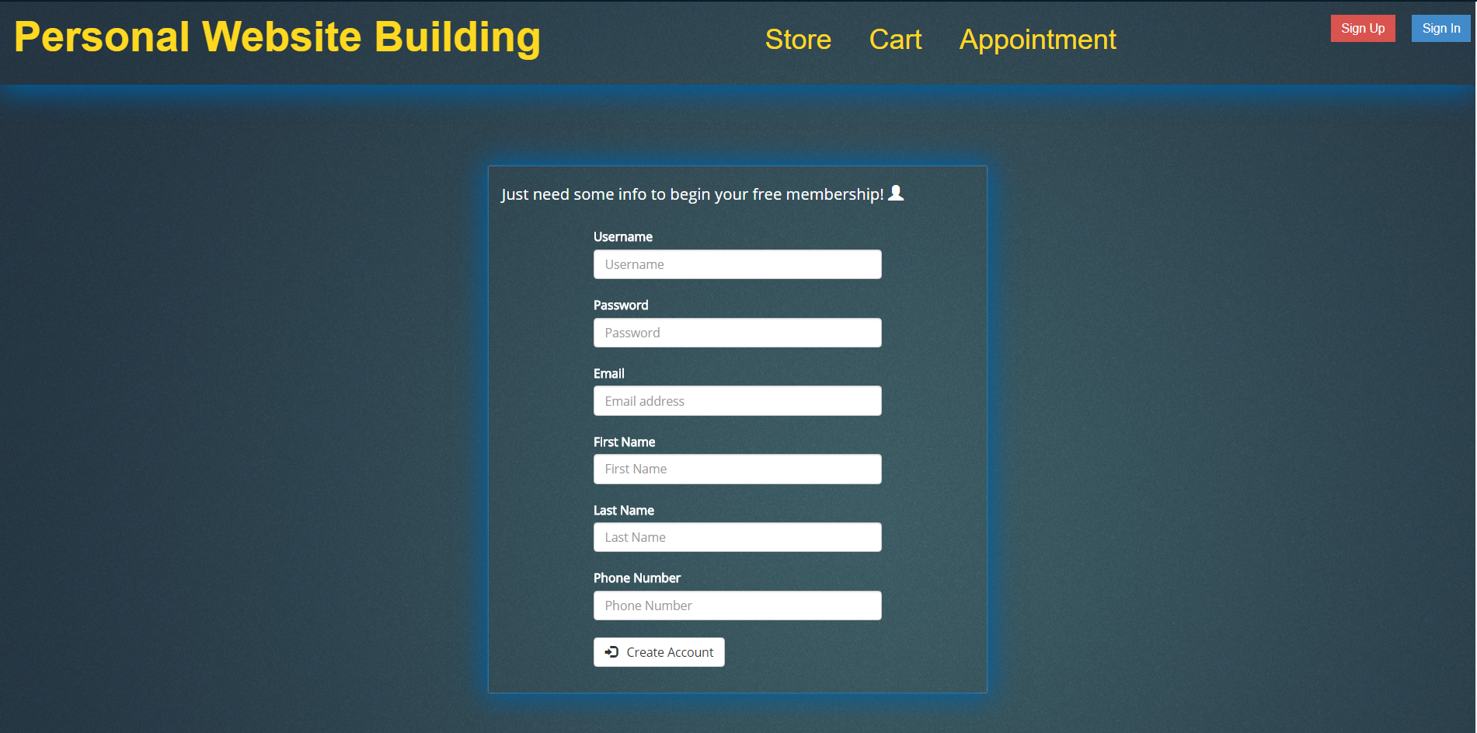

This is code that can’t be replicated without user input and a PHP script to insert the data into the database. There is also a select script that checks the database for a user’s email.

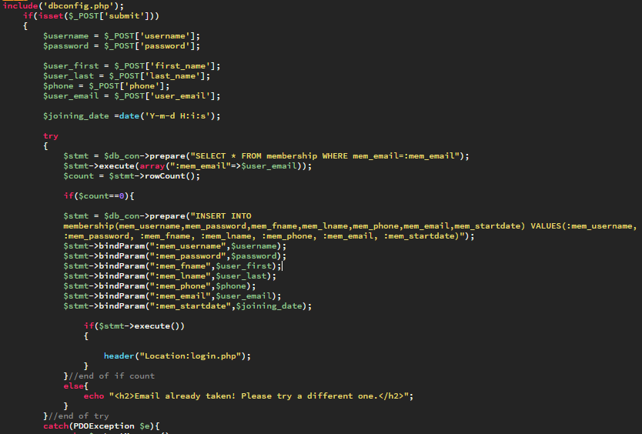

Login Page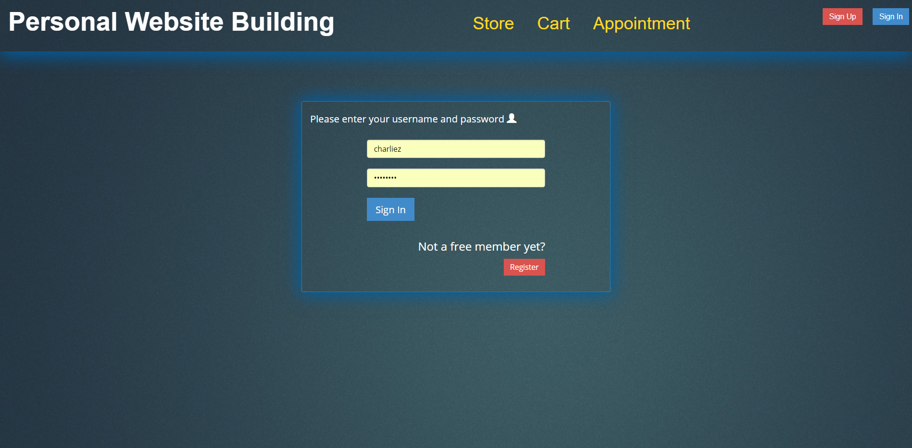

This page searches the database for a username and password. If they are an exact match, it will start a session with that users ID.

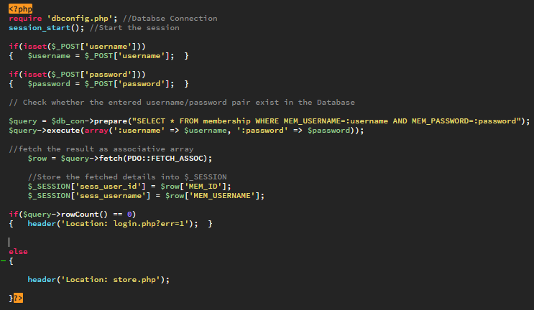

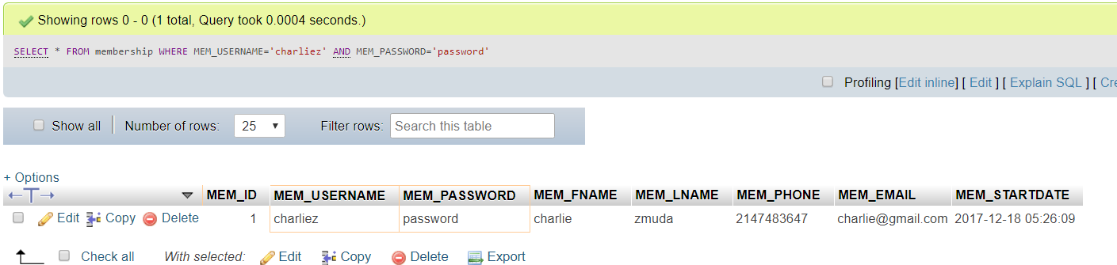

## Store Page

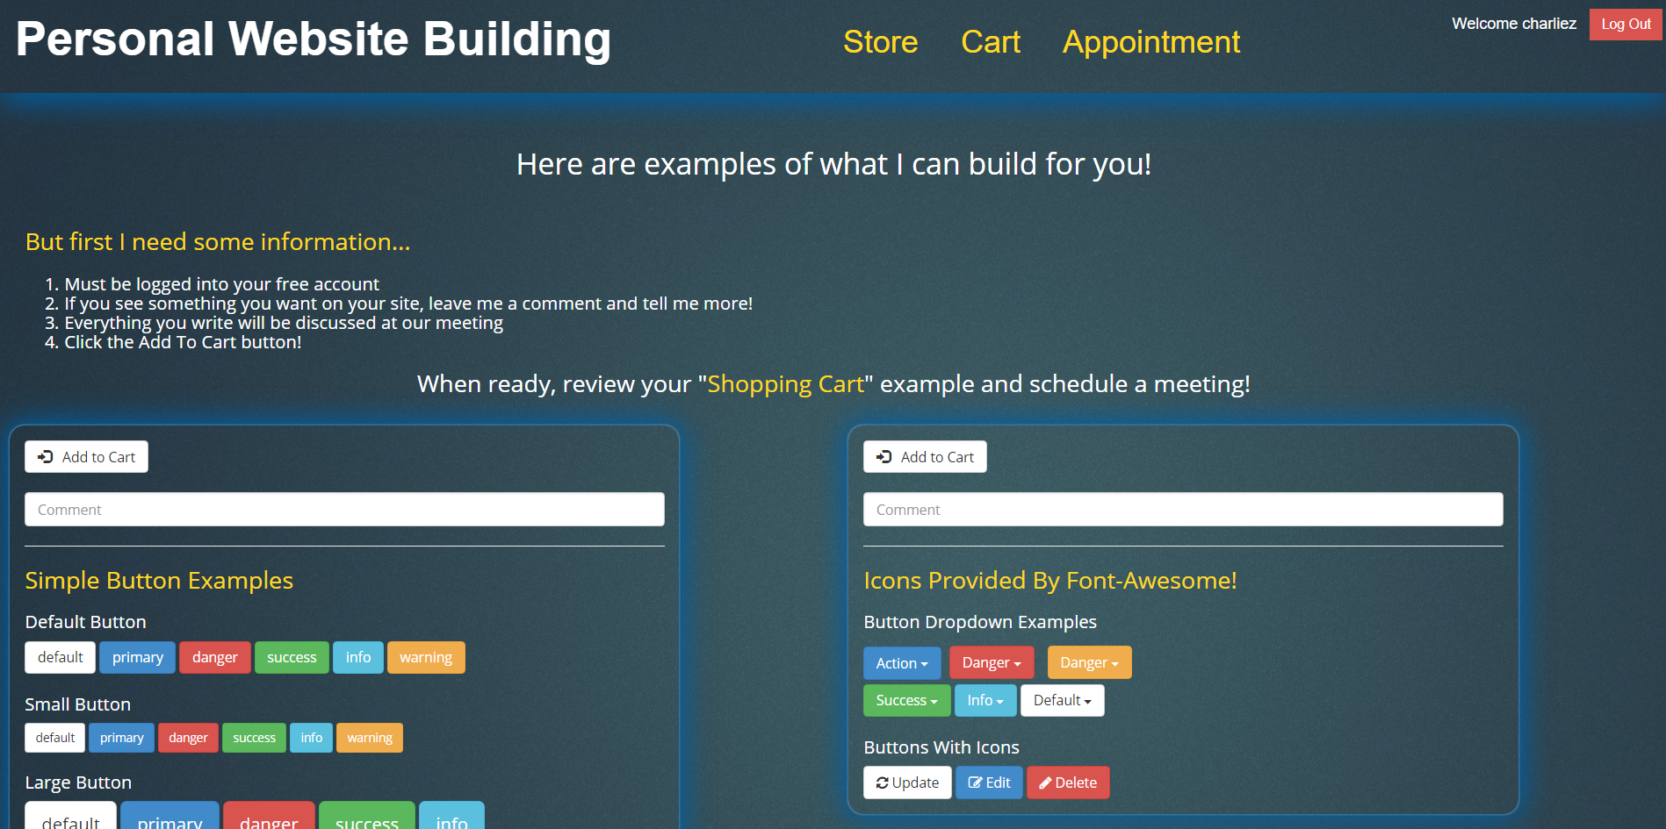

The store will show an Add To Cart button and comment box if the user’s credentials match at login. This button inserts the user’s $_SESSION id, the product id, and the comment into the Cart table.

## Cart Page

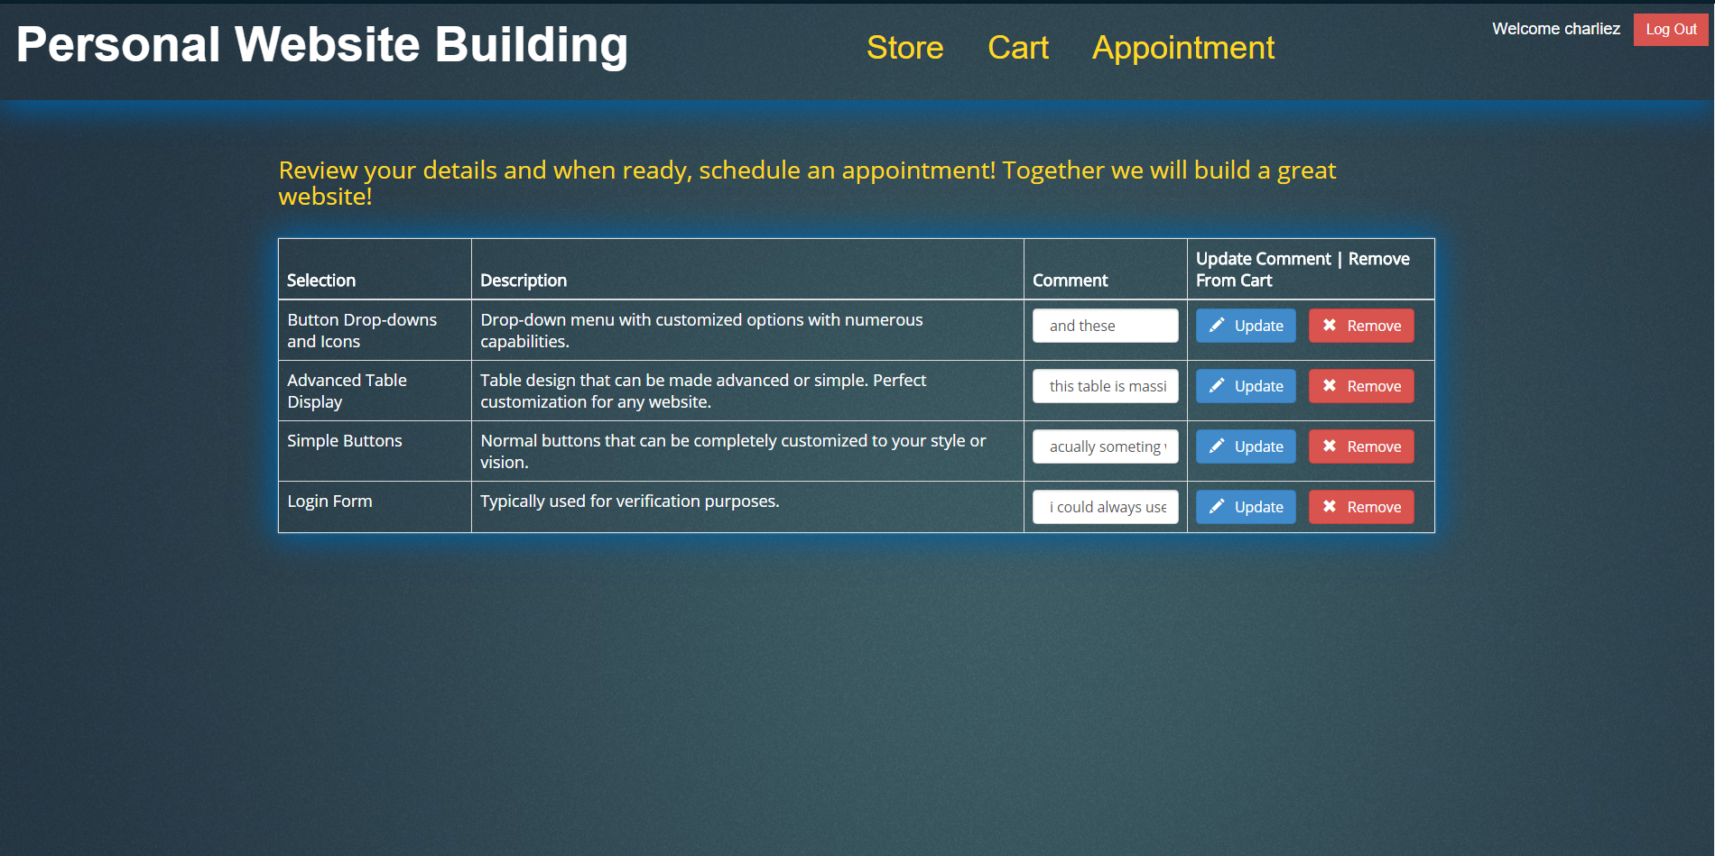

Output of the cart query with the number ‘1’ in place of ‘$mid’.

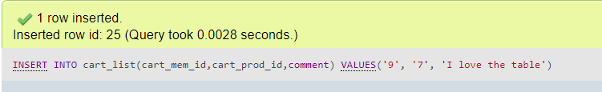

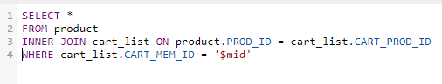

Output of the cart table query.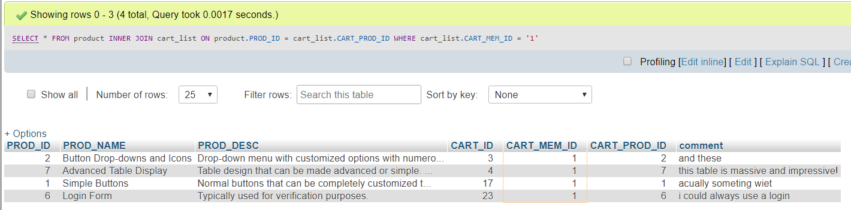

The delete button will use the carts id from a while loop that prints the items to the cart page. The id is used to delete the row.

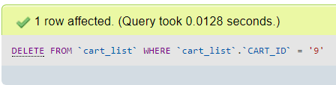

This updates the cart with a new comment that is found in the same row. It used the cart id to target the correct row and updates the comment accordingly.

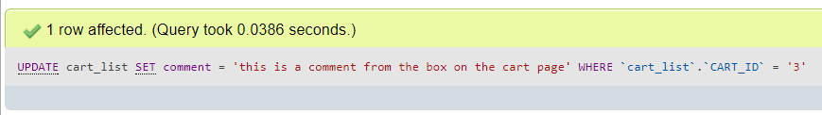

This shows the three queries used on the cart page.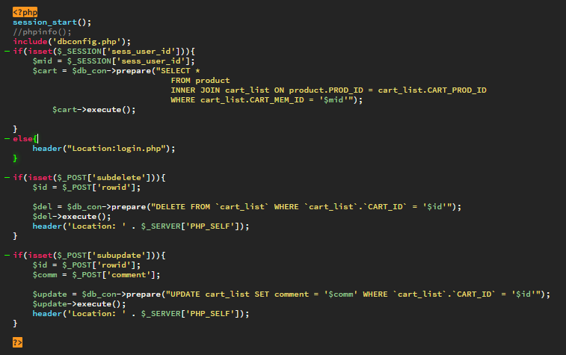

## Appointment Page

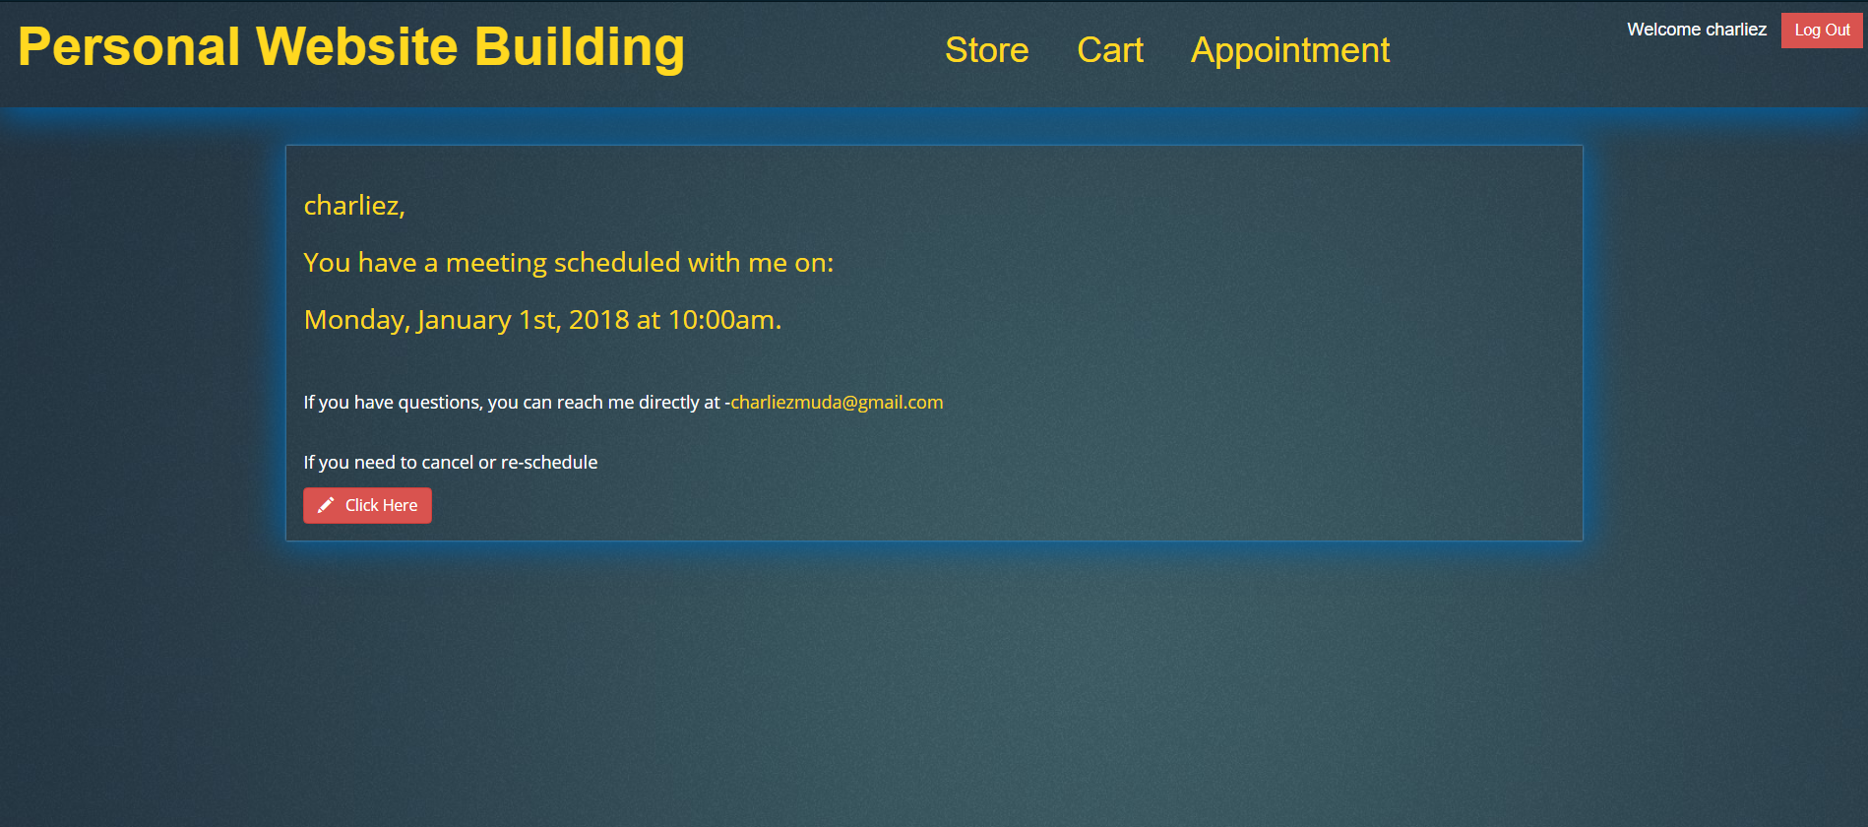

If the user’s id already exists in the appointment/calendar table, a message will display to the user. Below are the multiple queries used on this page.

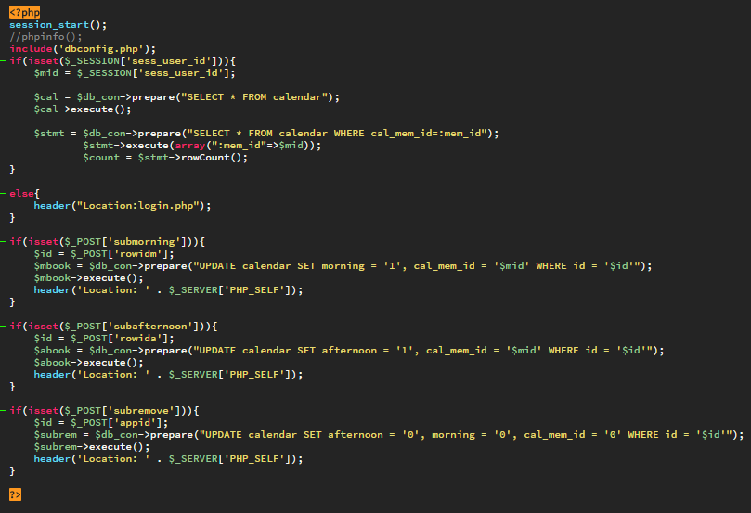

If the user does not have an appointment yet, the user will see the appointment page. Here the table uses a select statement to display the table. If the morning column was booked by someone else, then a disabled reserve button shows which prevents any conflicts with the appointments.

If the user clicks on one of the book buttons, the calendar table gets updated with a binary value. If the time slot is available, it is set to 0 if it is taken, it is set to one. It than records the users id as well, so the I am able to look up there membership information before the appointment takes place.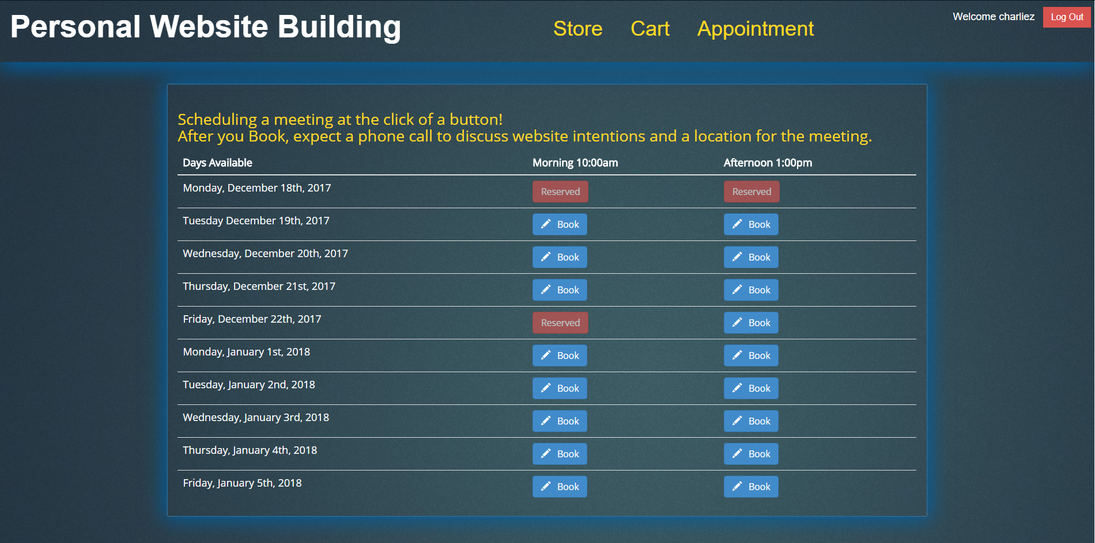

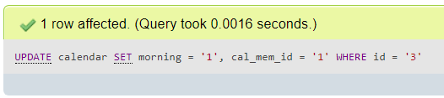

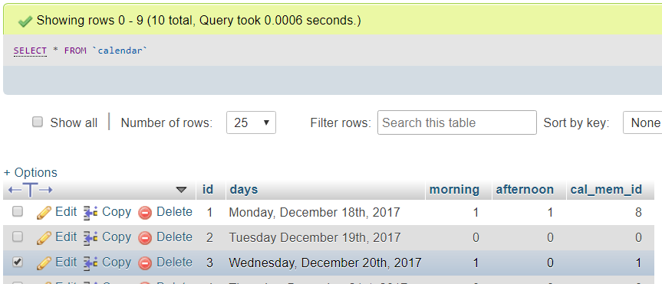

Here you can see the output and the change that has been made to the cart page to Wednesday, December 20th, 2017 row. The book button is now reserved and if that user checks, it will show a message confirming their appointment and has a button for canceling the appointment.

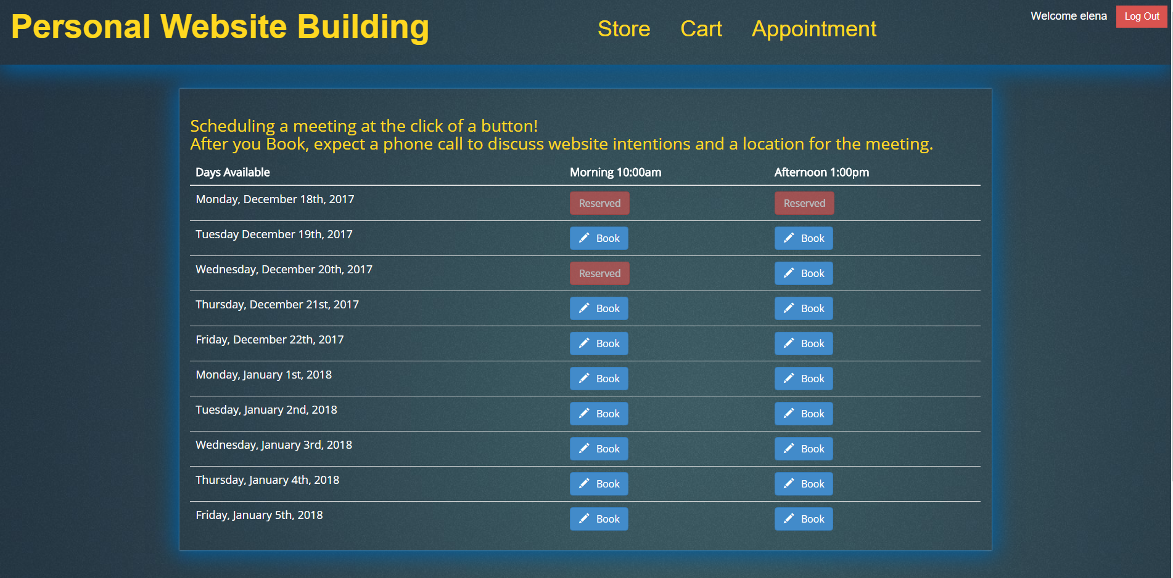

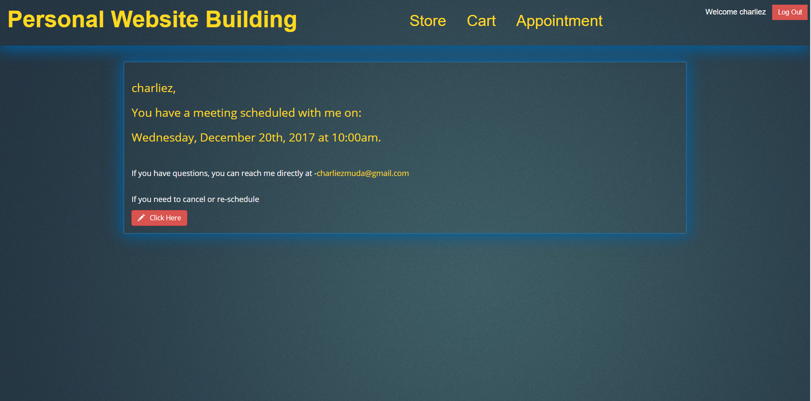

# Appendices

## Appendix A: References

TMD Hosting for hosting my website files and databases.

<https://portal.tmdhosting.com/>

W3Schools website was used for a lot of references of code structure

<https://www.w3schools.com/>

Tutorialspoint website was used for PHP scripts.

<https://www.tutorialspoint.com/php/>

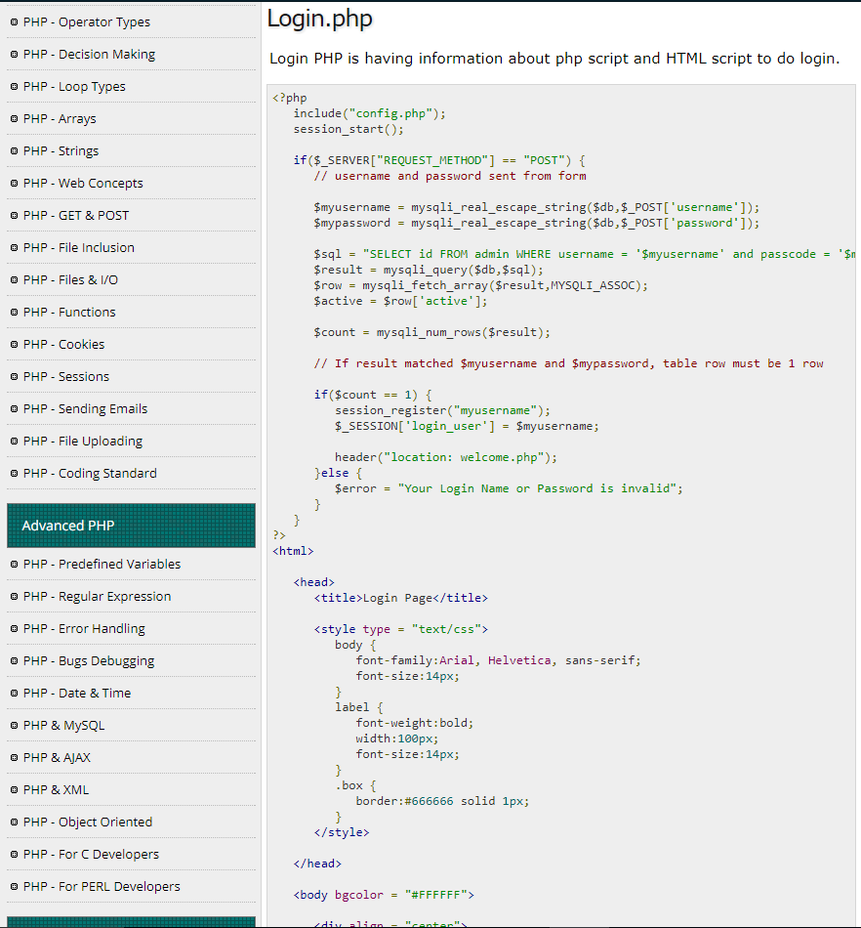

I also used phpMyAdmin for just about everything database and hosting. It is the one pillar that holds everything together.

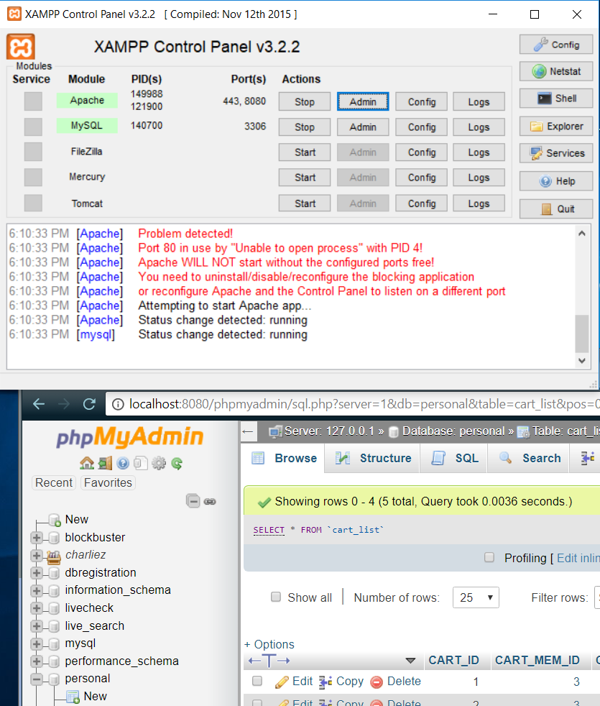

For learning more about all kinds of functions in PHP and confirming accuracy of code and version control.

<http://php.net/manual/en/funcref.php>

And learning more about security with connections

<http://php.net/manual/en/pdostatement.bindparam.php>

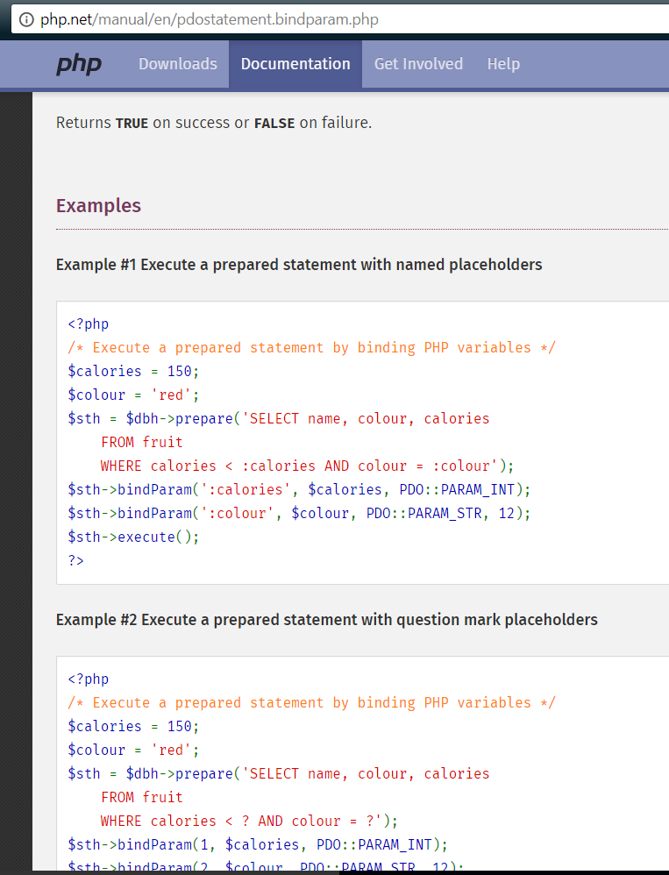

I used a Bootstrap template completely free and open for public use. Compliments of Binary Admin.

<http://binarycart.com/>

I used the website resource Cloudways for more clarification on forms and SQL queries.

<https://www.cloudways.com/blog/custom-php-mysql-contact-form/#e>

And lastly I used the resources at Dunwoody that was provided from the class and instructors.